Shubham Goswami

Sujin Park

Vigneshwaran Giri Velumani

**INSTAGRAM ANALYTICS TO IDENTIFY DIGITAL OPIOID ACCESS**

Table of Contents

ABSTRACT 3

Results 3

INTRODUCTION 4

PROCESS FLOW 5

Hashtag Collection 6

Instagram Posts and Comments Extraction 7

Data Preprocessing 7

Data Filtering 9

Classification 10

MODELING 11

Selling 12

Consumers 13

Experience Sharing 13

News_Awareness 14

Others 14

ANALYSIS 15

Analysis of Selling Category 16

Analysis of Opioid Sellers & Posts 17

Analysis of Marijuana Selling Posts 23

Insights of Opioid Vs Marijuana posts 27

Analysis of Consumers 28

Analysis of Experience Sharing 30

FUTURE SCOPE 34

Insights 34

APPENDIX 35

CODE: for Aggregating All Extracted Text (Posts and Comments) 35

CODE: for Cleaning and Stemming 37

CODE: for Filtering and Scoring 38

CODE: for Reducing Multiple Buckets into Five Buckets 42

CODE: for Analyzing Sub-categories per Each Bucket 46

REFERENCES 48

# ABSTRACT

Instagram is one of the major social media platforms and being used for opioid selling as well as by consumer feedback, we aimed to develop a solution to identify and classify Illicit Online Marketing and Sales of Controlled Substances via Instagram.

We extracted opioid-related posts data using Phantombuster API which included a feature ‘postUrl’ through which we extracted the comments linked to the posts.

We then cleaned and pre-processed the data including data stemming for getting the root words to make it usable for our text mining analysis.

In order to get the relevant posts, we created a bag of words for each category that we were interested in and stemmed the words in the bag of words as well to compare it with the extracted texts. Comparing the stemmed bag of words with the stemmed texts helped us to get a score of the words in each text corresponding to the category, making us identify the relevant posts.

After getting the relevant data, we manually classified an equal proportion of texts in each category so that we could use that data to train a Google AutoML model for classifying the texts into the relevant buckets. The 5 categories identified by us were: Selling, Consumers, Experience Sharing, News/Awareness, and Others.

After classification of the texts, we aimed to analyze the buckets, especially selling and consumers to get more insights on the pattern and behaviors of the sellers and consumers.

## Results

We manually extracted the profiles of the sellers to find more details about them (Contact Information, website, etc.) and consumer characteristics.

# INTRODUCTION

Instagram, the photo- and video-sharing platform, is undoubtedly the hottest social media outlet on the market right now. In fact, it's doubled its user base in just two short years, to 800 million, 500 million of whom are daily users.

Reports consistently show that Instagram has the most engaged community on the internet: The platform's posts receive more engagement than any other social network out there -- 84 times more than Twitter, 54 times more than Pinterest and 10 times more than its older sibling, Facebook.

Although praised for its influence, Instagram has been the subject of criticism, most notably for policy and interface changes, allegations of censorship, and illegal or improper content uploaded by users.

In recent years the number of opioid-related deaths, hospitalizations and overdoses have increased. By 2017, all the provinces continued to see large increases in the number of opioid-related deaths. Timely data on opioid-related overdoses would be invaluable in monitoring trends and supporting effective responses to the crisis.

Traditional methods of surveying opioid use include nationwide surveys and administrative databases documenting opioid-related deaths and overdoses. Although informative, limitations to these sources include delay in the access to data or in the publication of results, response bias affecting survey results, and the lack of detailed information on the context surrounding opioid use.

Social media has been previously used as a tool to provide data on urgent public health issues. Previous studies have utilized social media for the epidemiological monitoring of diseases and to gauge public reactions to health promotion efforts. In recent years, the use of Instagram in research has increased, compared with other social media, due to the high volume of posts and ease in accessing and searching Instagram data.

With the current opioid crisis, the public perceptions and documented use of opioids by the Instagram users could inform responses to the crisis and identify Instagram users’ reactions towards current efforts. This project examines Instagram data to do with opioid use and selling.

# PROCESS FLOW

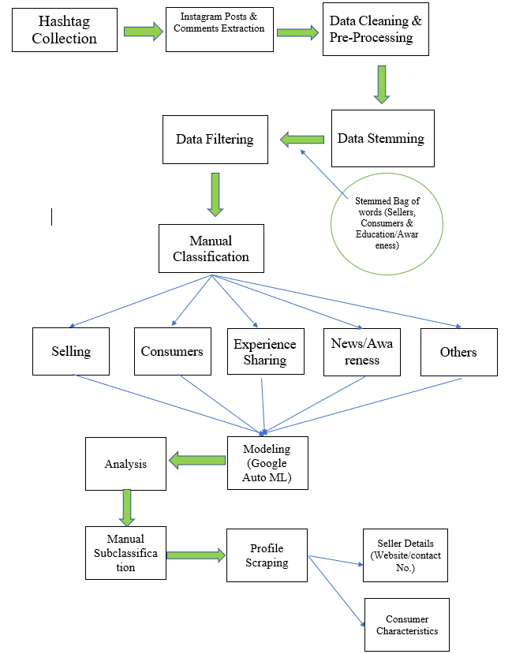

## Hashtag Collection

We listed the relevant Instagram hashtags, which serve as a set of keywords to extract the Instagram posts. Initially, the list was developed by reviewing the published sources. Based on the small set of keywords, we extended the list of hashtags while going through the Instagram posts. Since Instagram does not allow users to search the controlled substance directly, we carefully examined the hashtags a few sample opioid-related posts were using. As a result, we found a total of 57 hashtags (see Table A).

Table A. The List of Hashtags

|  |  |
| --- | --- |
| Hashtags | |
| #ApacheChine | #oxycon |
| #cannabissmoker | #oxycondone |
| #CaptainCody | #oxycontin |
| #Carfentanil | #oxycontin40mg |
| #codeine | #oxycontinblues |
| #Dope | #OXYCONTINS |
| #drinkinglean | #Painkiller |
| #EmpirinwithCodeine | #PancakesandSyrup |
| #fentanly | #percocert |
| #heroin | #percocet |
| #hydrocodone | #percs |
| #hydrocodoneacetaminophen | #Percs |
| #itsmorphinetime | #percsfordays |
| #jualtramadol | #percshot |
| #jualtramadol50mg | #percsonpercs |
| #jualtramadolonline | #promethazineandcodeine |
| #methaddict | #promethazinewithcodeine |
| #methadone | #Subsys |
| #morphine | #TangoandCash |
| #OC | #TNT |
| #Opana | #tramadol |
| #opioid | #Tylenol3 |
| #oramorph | #Tylenol3s |
| #oxy | #Ultracet |
| #Oxy | #vicodinhigh |
| #Oxy80 | #white |
| #oxycodone | #zomorph |

## Instagram Posts and Comments Extraction

To extract the Instagram posts with the relevant hashtags, we have used Phantombuster’s Instagram Hashtag collector which is ready-made cloud API. This Instagram API requires users to provide a spreadsheet containing the hashtags which are of interest and their Instagram session cookies to extract the posts on Instagram. As an output, this API could offer several fields, including post description, postUrl, profileURL, and so forth. We have collected a total of 104,014 Instagram posts from December 2011 to April 2019 for 2 weeks. All the extracted posts were stored as CSV MS Excel file.

In addition, we have collected the comments data of each extracted Instagram post. We noticed that instead of uploading their post, sellers tend to display their personal contact information through the comments. We have used Phantombuster’s Instagram Auto Commenter API to collect the comments on the extracted posts. It is necessary for users to provide the link of a Google Spreadsheet with Instagram posts URLs and their session ID. A total of 79,356 comments were collected and saved as CSV MS Excel file as well.

To create a single set of data for the analysis, the posts and comments dataset have been combined with the common column ‘postUrl’. After removing the duplicated rows and unnecessary columns, we ended up getting a dataset with 166,401 rows and three columns including postUrl, text, and type.

## Data Preprocessing

Instagram posts and comments generally include emoji, emoticons, URLs, hashtags, punctuation marks, and stop words. These issues should be dealt with and eliminated before the process of stemming and classification. Using tm package in R, we cleaned the data and prepared it to be ready for further analysis. We have first converted the entire text to lowercase so that the same words such as ‘Opioid’ and ‘opioid’ are considered as same. Next, we have removed URLs, emoji, hashtag, extra newlines, and all punctuations. After eliminating the unnecessary components, we also removed stop words which are commonly used words but have very little meaning, such as ‘and’ and ‘or’.

To avoid considering the words with different verb tenses differently, we have performed stemming on the text using Porter's stemming algorithm. For instance, if we stem words such as “leaning”, it would be transformed into the root word “lean” (see Table B). We also have applied the same stemming process for the bag of words and came up with the stemmed bag of words per each bucket. Comparing the stemmed text with the stemmed bag of words, the opioid-related text will be distinguished from the irrelevant text (see Table C).

Table B. Data Preprocessing

|  |  |
| --- | --- |
| Original Text | **This week special** BUY one GET one free. UDT tablet contains tramadol Hcl, which is a narcotic-like pain reliever. Ultram is used to treat moderate to severe pain for knee pain relief, and constipation pain relief..... Visit Tramadolshop.is to Grab the deal Now!#deal #discount #painkiller #pain #medicine #onlinepharmacy #medatyourdoor #medicinediscount #pharmacy #painreleif #painkillers #painrelief #buyonegetonefree #healthcare #healthcaresolution |
| Transform to Lowercase | **this week special** buy one get one free. udt tablet contains tramadol hcl, which is a narcotic-like pain reliever. ultram is used to treat moderate to severe pain for knee pain relief, and constipation pain relief..... visit tramadolshop.is to grab the deal now!#deal #discount #painkiller #pain #medicine #onlinepharmacy #medatyourdoor #medicinediscount #pharmacy #painreleif #painkillers #painrelief #buyonegetonefree #healthcare #healthcaresolution |
| Remove Punctuation and Marks | this week special buy one get one free udt tablet contains tramadol hcl which is a narcotic like pain reliever ultram is used to treat moderate to severe pain for knee pain relief and constipation pain relief visit tramadolshopis to grab the deal now deal discount painkiller pain medicine onlinepharmacy medatyourdoor medicinediscount pharmacy painreleif painkillers painrelief buyonegetonefree healthcare healthcaresolution |
| Remove Stopwords | week special buy one get one free udt tablet contains tramadol hcl narcotic like pain reliever ultram used treat moderate severe pain knee pain relief constipation pain relief visit tramadolshopis grab deal now deal discount painkiller pain medicine onlinepharmacy medatyourdoor medicinediscount pharmacy painreleif painkillers painrelief buyonegetonefree healthcare healthcaresolution |
| Stemming | week special buy one get one free udt tablet contain tramadol hcl narcot like pain reliev ultram use treat moder sever pain knee pain relief constip pain relief visit tramadolshopi grab deal now deal discount painkil pain medicin onlinepharmaci medatyourdoor medicinediscount pharmaci painreleif painkil painrelief buyonegetonefre healthcar healthcaresolut |

Table C. Sample of Bag of Words and Stemmed Bag of Words

|  |  |  |  |  |  |
| --- | --- | --- | --- | --- | --- |
| Sellers | | Consumers | | Education/Awareness | |
| Original | Stemmed | Original | Stemmed | Original | Stemmed |
| Prescription | prescript | Failure | failure | Educate | educ |
| Buy | buy | Hate | hate | Awareness | awar |
| Cheap | cheap | Afraid | afraid | Rehab | rehab |
| Price | price | Agony | agoni | Centres | centr |
| Discount | discount | Danger | danger | Recover | recov |
| Delivery | deliveri | Humiliation | humili | Wellness | well |
| Gree | free | Alone | alon | Cure | cure |
| Shipping | ship | Vulnerable | vulner | Help | help |
| Door | door | Stress | stress | Community | community |
| Sale | sale | Pitfall | pitfall | Article | articl |
| Deal | deal | Mistake | mistak | Post | post |
| Offer | offer | Risk | risk | Press | press |
| Pay | pay | Devastating | devast | Magazine | magazine |
| Credit | credit | Stupid | stupid | Abolish | abolish |
| Cash | cash | Warning | warn | Fight | fight |
| Sell | sell | Addict | addict | Define | defin |
| Debit | debit | Pain | pain | Safe | safe |
| Accept | accept | Pill | pill | Treat | treat |
| Card | card | Relieve | reliev | Message | messag |
| Online | onlin | Withdrawal | withdraw | News | news |
| Email | email | Euphoria | euphoria | Care | care |
| Text | text | Combination | combin | Overdose | overdos |
| whatsapp | whatsapp | Inject | inject | Abuse | abus |

## Data Filtering

We created a function that gets two parameters as inputs: one is the text of the combined posts and comments (166401 Observations) the other is the list of words in the bag for each bucket-Seller, Consumer and Education Awareness that was scanned from the CSV file created in the previous step. Then through the code, it matched the text with any word in the bag of words and then assign a score for the number of matched bag of words with the posts & comments text for each bucket. Once all the text is assigned a bucket score based on their match with words in each bucket, we retrieve the texts which have a score of more than 0, i.e., the relevant texts which have at least one word in the bag of words that matched. Each text was grouped either as a Seller or a Consumer or Education/Awareness text based on the maximum score that a text has out of all the buckets [Figure.1]. Those texts that had scores of Zero were labeled “Others” and were removed. We retrieved 47112 Observations after filtering out the “Others” texts.

Figure.1 Data Filtering using Scoring in Three Different Buckets

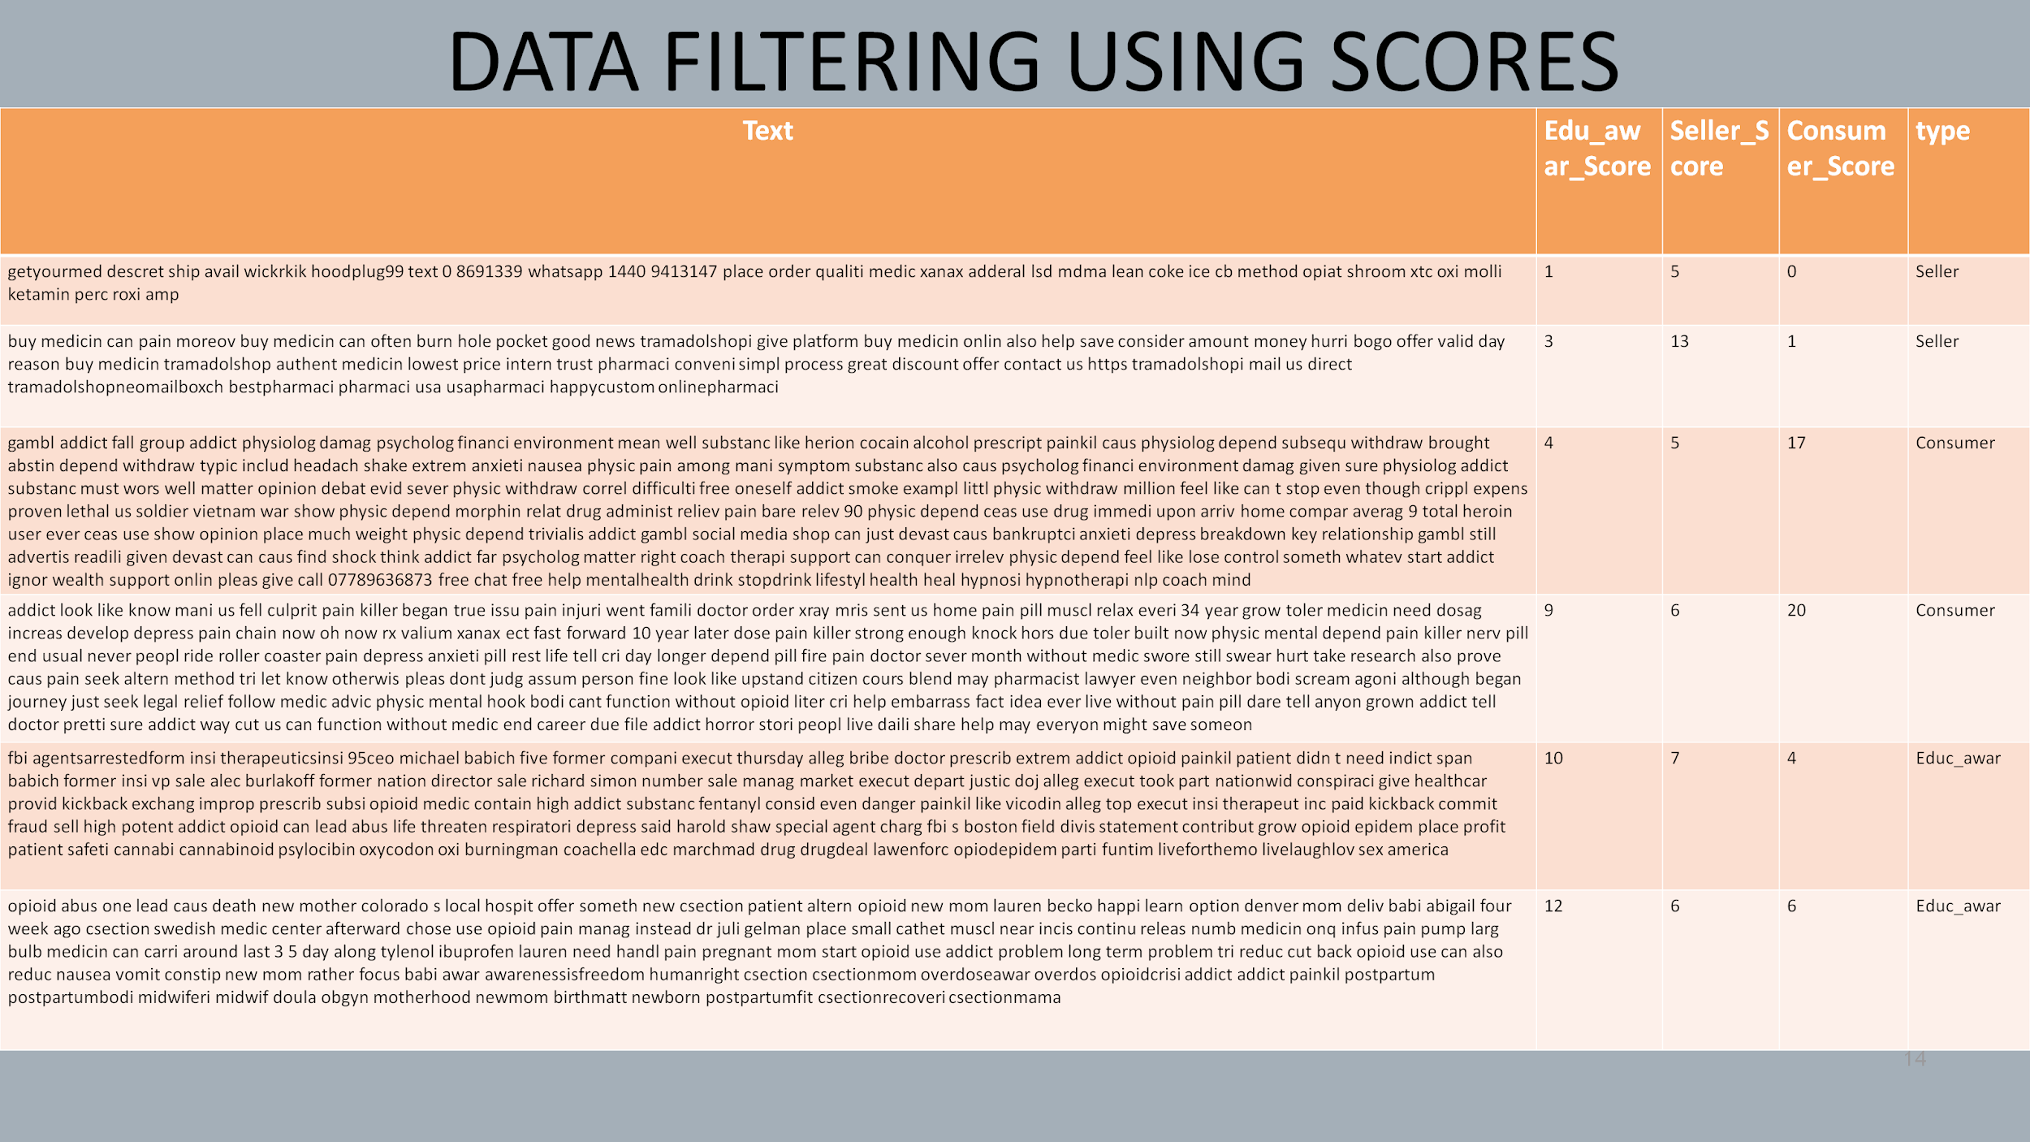

## Classification

We mapped the 47112 observations with their original text which was extracted from the API and manually classified 3747 observations into five buckets namely:

Selling - 116

Consumers - 252

Experience Sharing - 126

News/awareness – 150

Others – 3103

Selling:

Any text which contains the motive of selling controlled substances as well as marijuana and its related accessories, were manually classified as a Selling text.

Consumers:

Any text which contains the words related to wanting/showing interest in buying were classified as consumers.

Experience Sharing:

All texts which were sharing experience with these controlled substances as well as marijuana. These experiences included their personal as well as others experience.

News/awareness:

Texts related to creating awareness and news about opioids and details like sellers being busted, policies and government regulation informational posts, etc. were classified as News/awareness.

Others:

Those texts which were unrelated to the objective of the project were classified as Others.

# MODELING

Trained Google AutoML model using the sample of manually classified data

Selling - 116

Consumers - 150

Experience Sharing - 126

News/awareness – 151

Others – 150

Below is the overall output for the 2801 text items (out of ~13k) which were used for training the model:

Figure 2. Google Auto ML Results

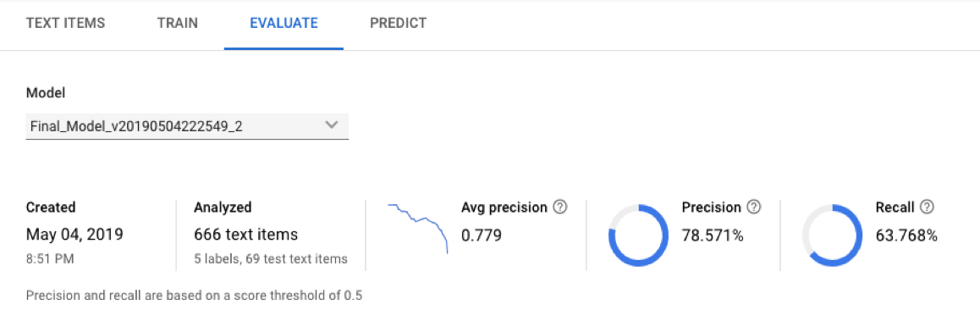

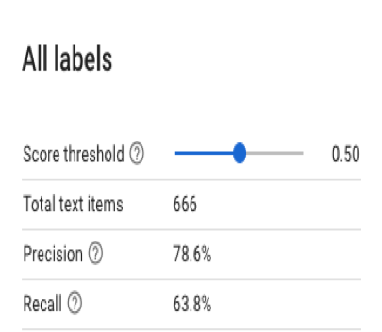

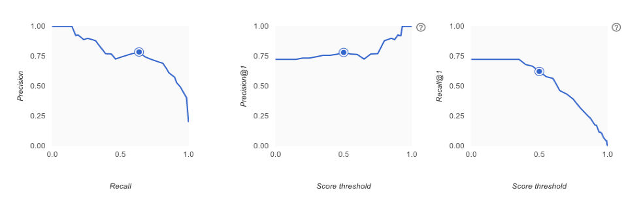

Note: Score threshold was set to 0.50 for all the labels.

The individual results for the 5 labels which were taken into account for the model are below:

## Selling

Figure 3. Selling Category

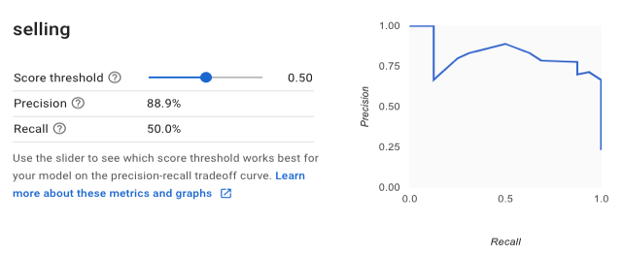

## Consumers

Figure 4. Consumers Category

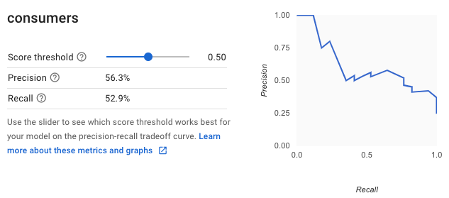

## Experience Sharing

Figure 5. Experience Sharing Category

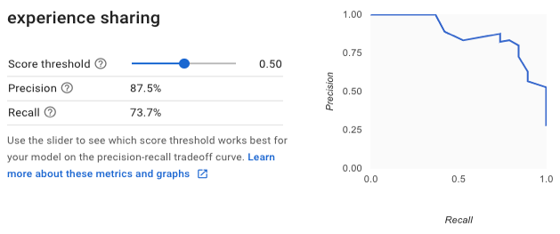

## News_Awareness

Figure 6. News/Awareness Category

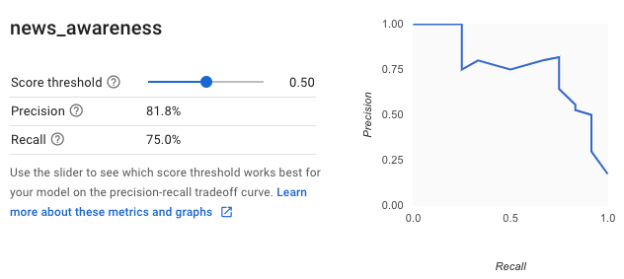

## Others

Figure 7. Others Category

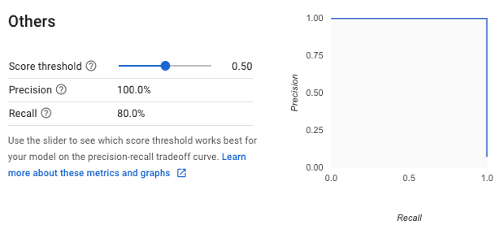

# ANALYSIS

We manually extracted the profileURLs from the postURLs of the text from the previous step. For this, we used profileURL in Phantombuster’s Instagram Profile Scraper API to extract the profile details of all Instagram users in each category. The data extracted from the API includes:

Table D. Phantombuster’s Instagram Profile Scraper API Output

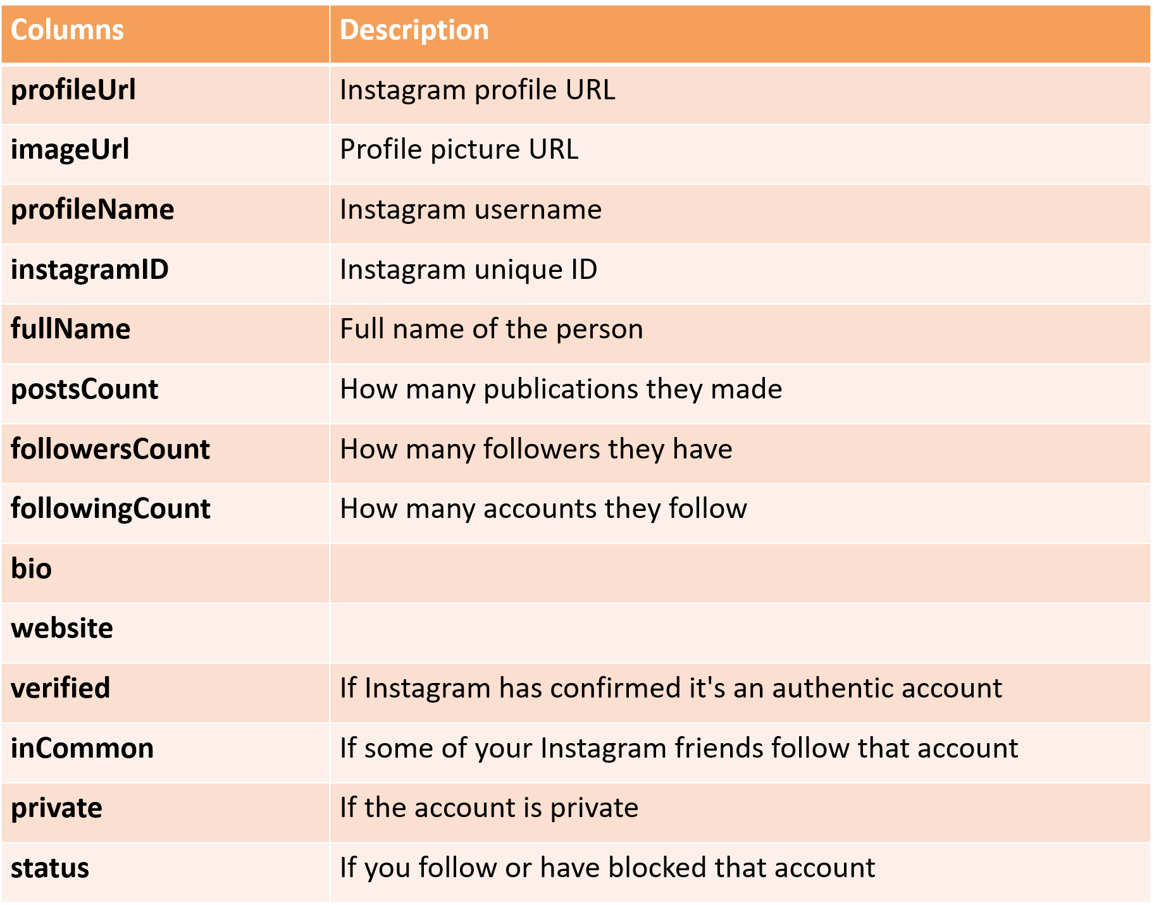

We are using postsCount, followersCount & followingCount in our analysis. Further, we manually identified and differentiated marijuana texts from opioid in Sellers and Consumers buckets in our first subclassification. As a second step, we created sub-categories in both Sellers and Consumers buckets under marijuana & opioid classifications. We analyzed Sellers and identified their website/links, email ids & contact numbers. We also analyzed Consumers’ characteristics.

## Analysis of Selling Category

We manually classified 116 Selling posts into 2 subcategories - marijuana & opioid in the first level and then we created subcategories under them as shown in Table.E below:

Marijuana

* Cbdoil
* Glasspipes
* Grower
* Manufacturer
* Smokeshop
* Vapecart
* Weed

Opioid

* Methylphenidate
* Promethazinecodeine
* Tramadol
* multiple

Table E. Sample Subclassification of Selling Posts into subcategories

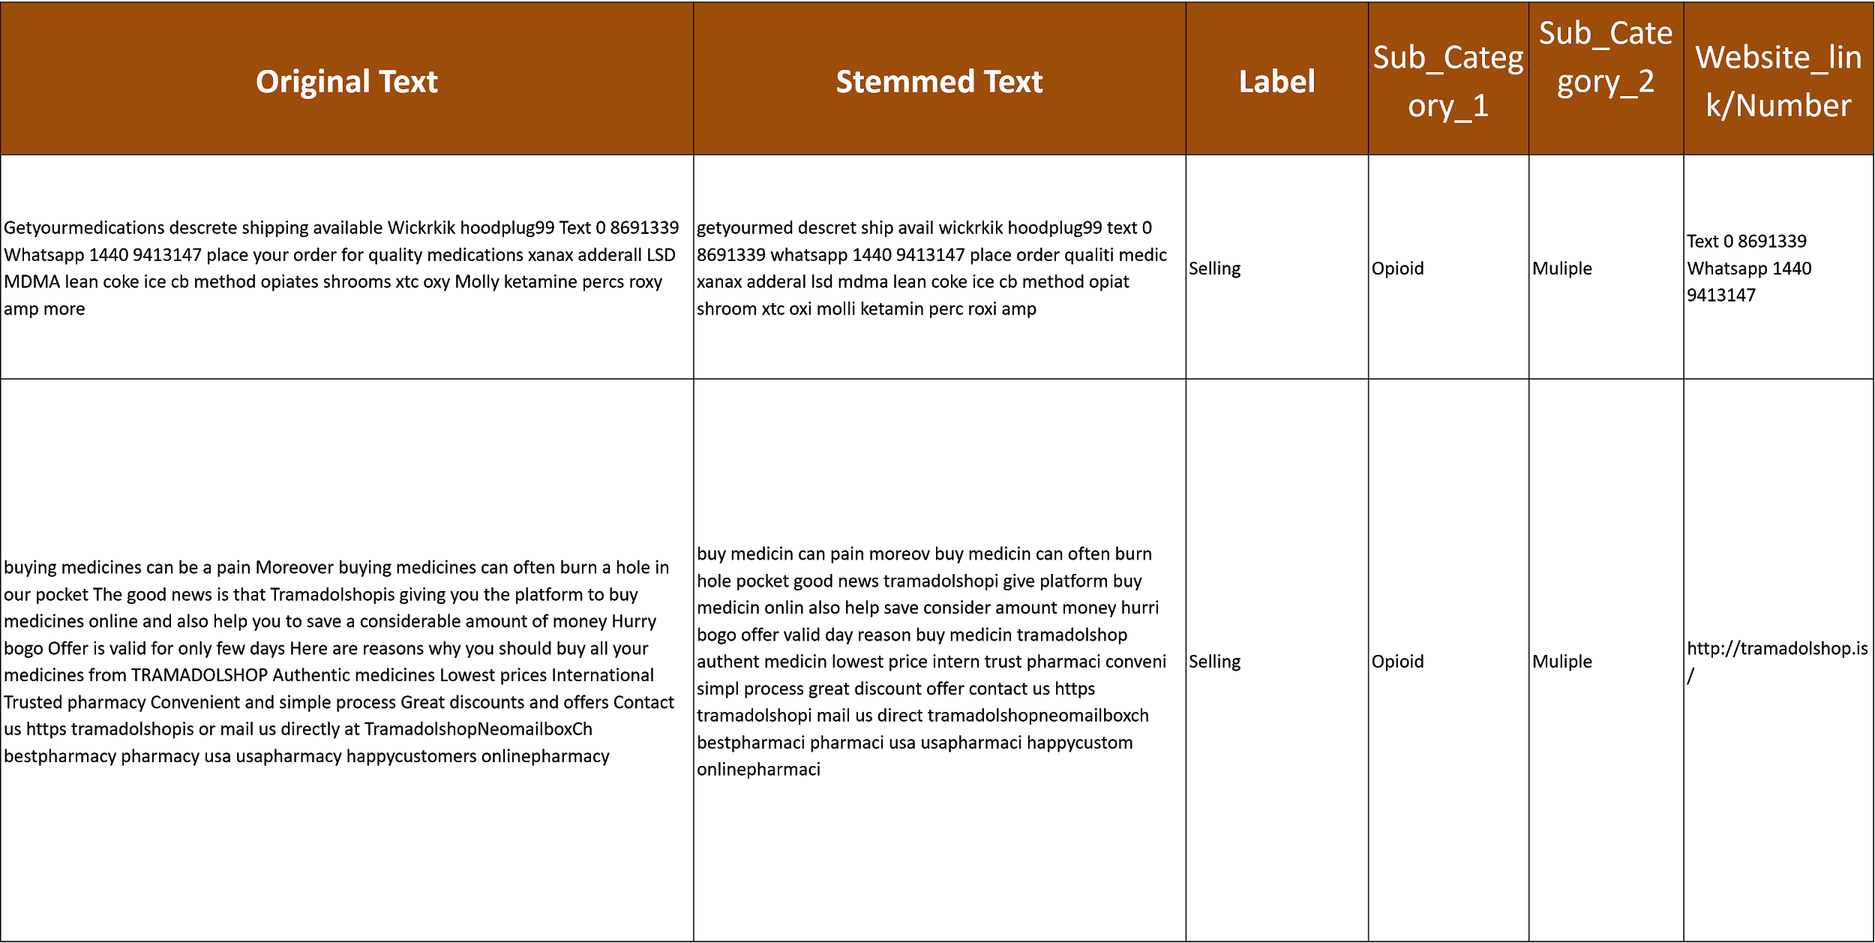

We found the distribution of marijuana & opioid texts to be highly skewed as shown in Figure 8 below:

Figure 8. Distribution of Opioid & Marijuana Texts

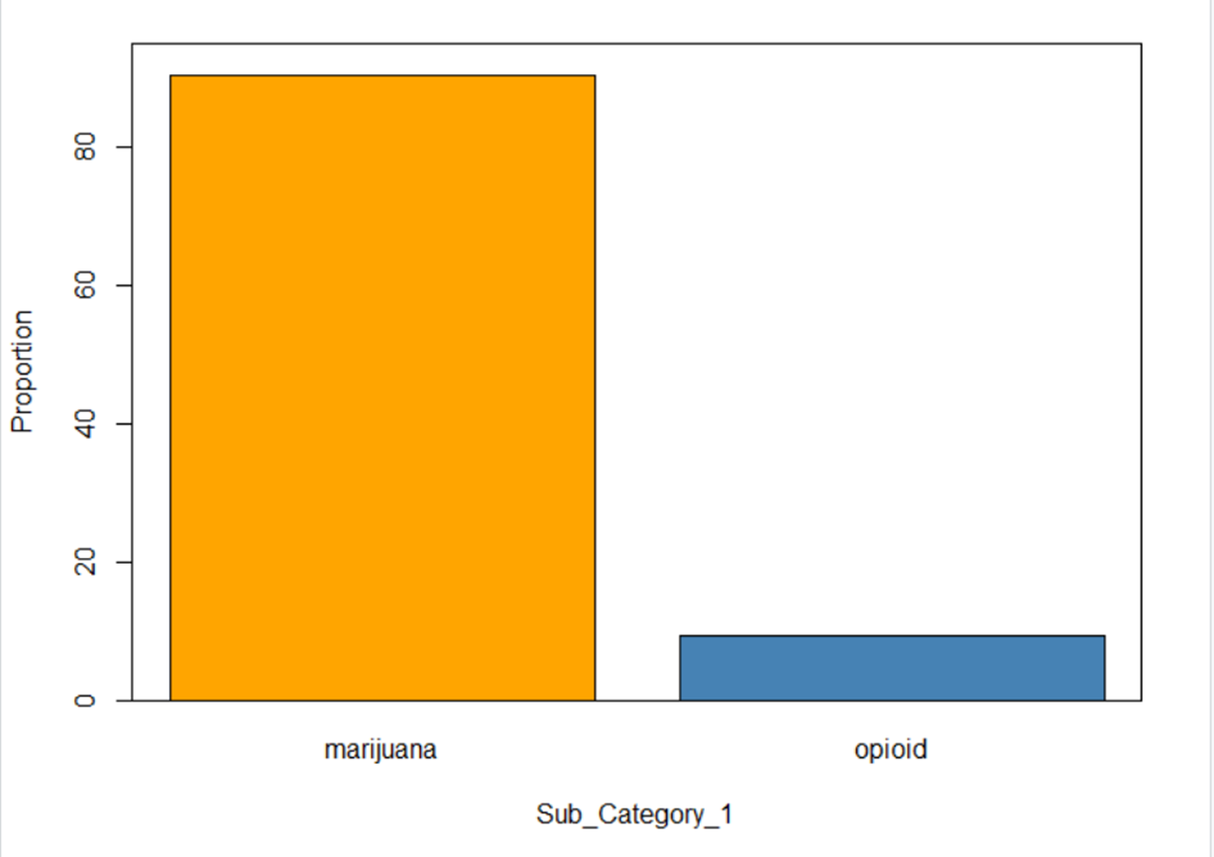

### Analysis of Opioid Sellers & Posts

We identified 10 sellers our of which 6 sellers in the training data sold multiple items in the opioid category. Also, tramadol seller had the maximum number of posts. Sellers under multiple category did not post anything rather they comment on other’s posts as shown below [Figure 9].

Figure 9. Distribution & Posts Count of Opioid Sellers

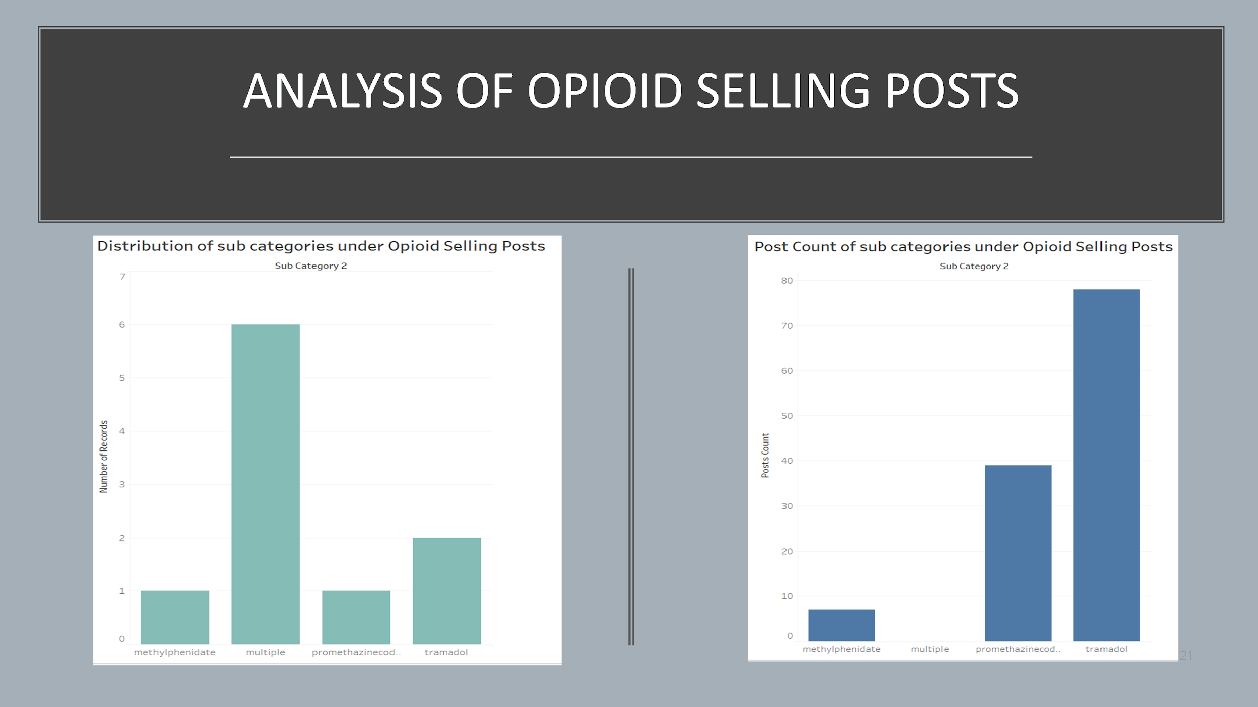

We found that the seller who was selling promethazinecodeine had the highest followers count whereas the tramadol seller had the highest following count as shown in Figure 10 below:

Figure 10. Followers Count & Following Count Distribution of Opioid Sellers

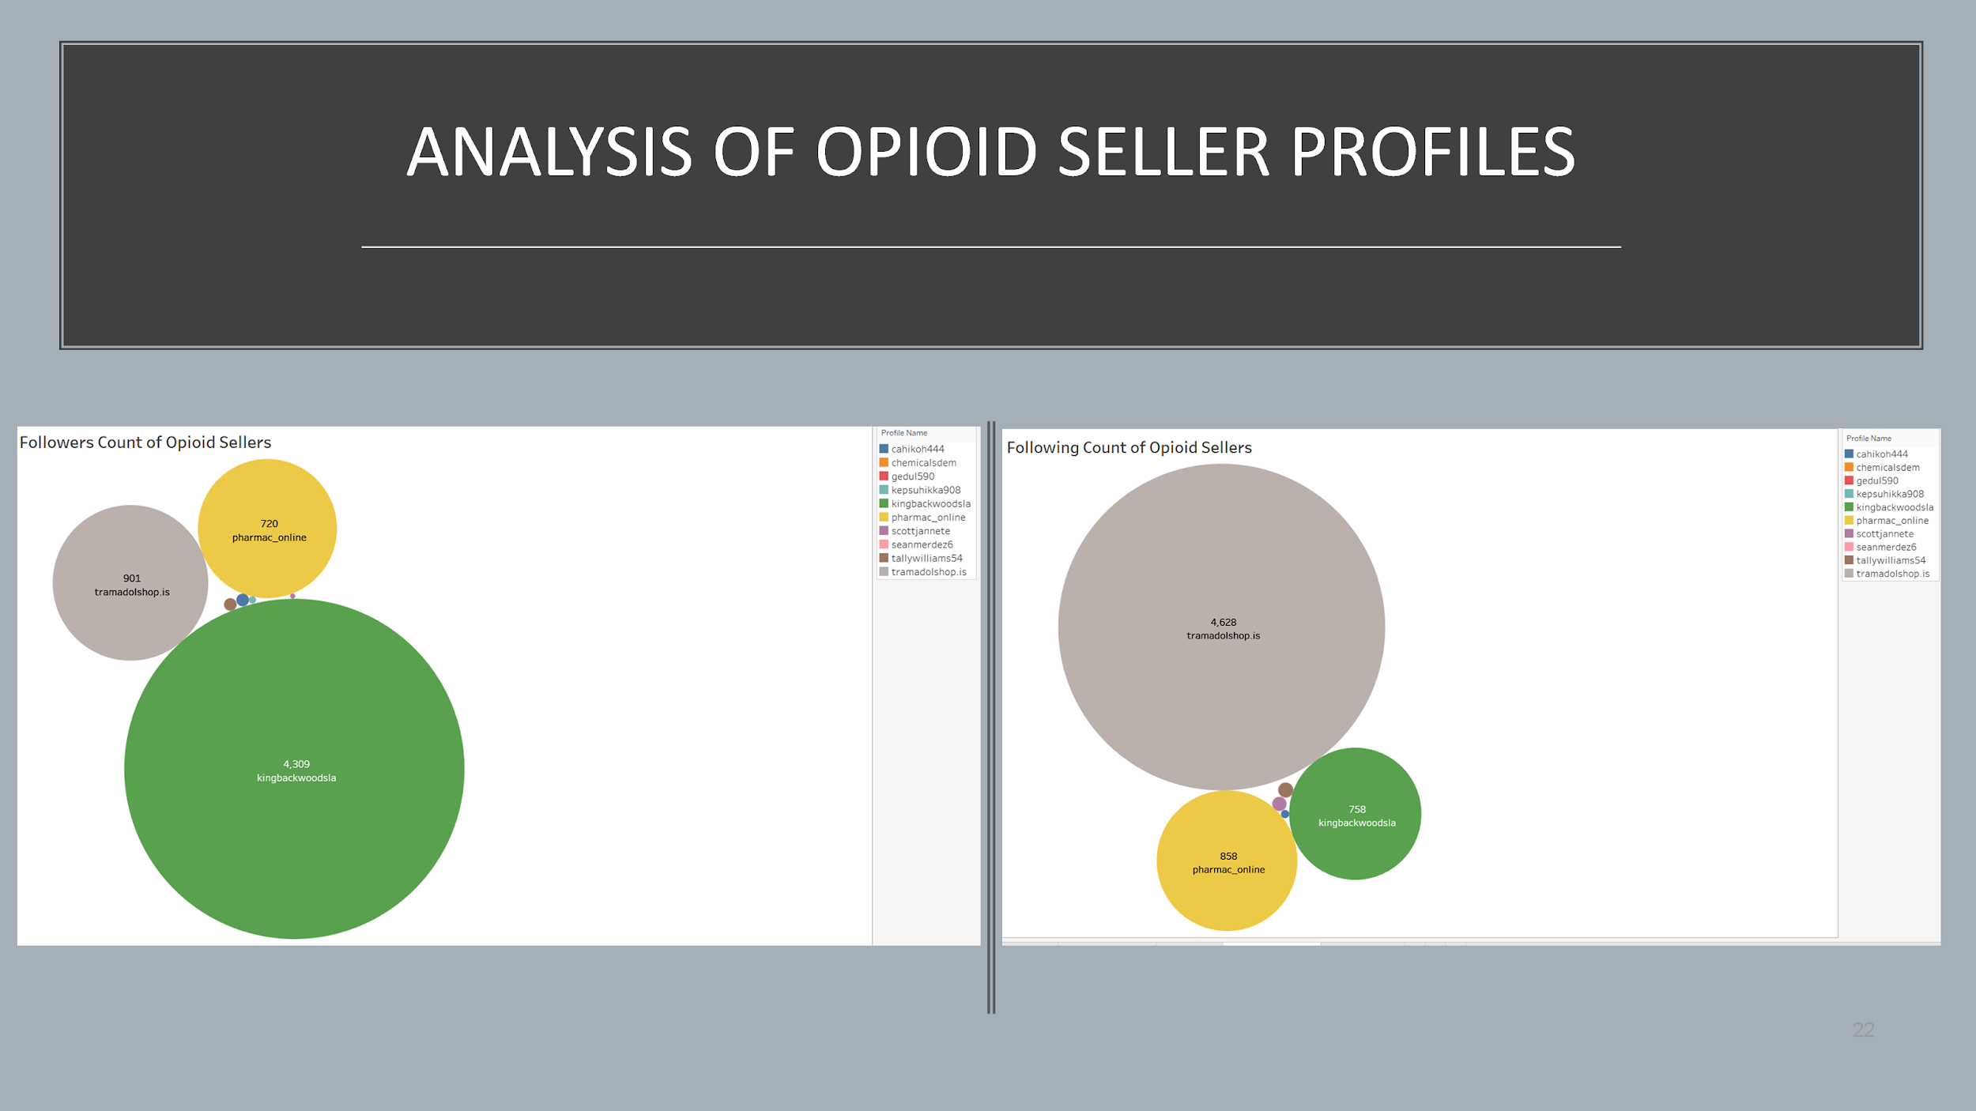

We found the profile creation date of the sellers manually using the website: 123accs.com. From the timeline graph, we can see that 70% of the sellers have created their profiles in the past 6 months. So, the opioid sellers create fake profiles when they are up to selling drugs online and they just comment on the posts rather than themselves posting about selling opioid posts.

Figure 11. Timeline of Profile Creation of Opioid Sellers

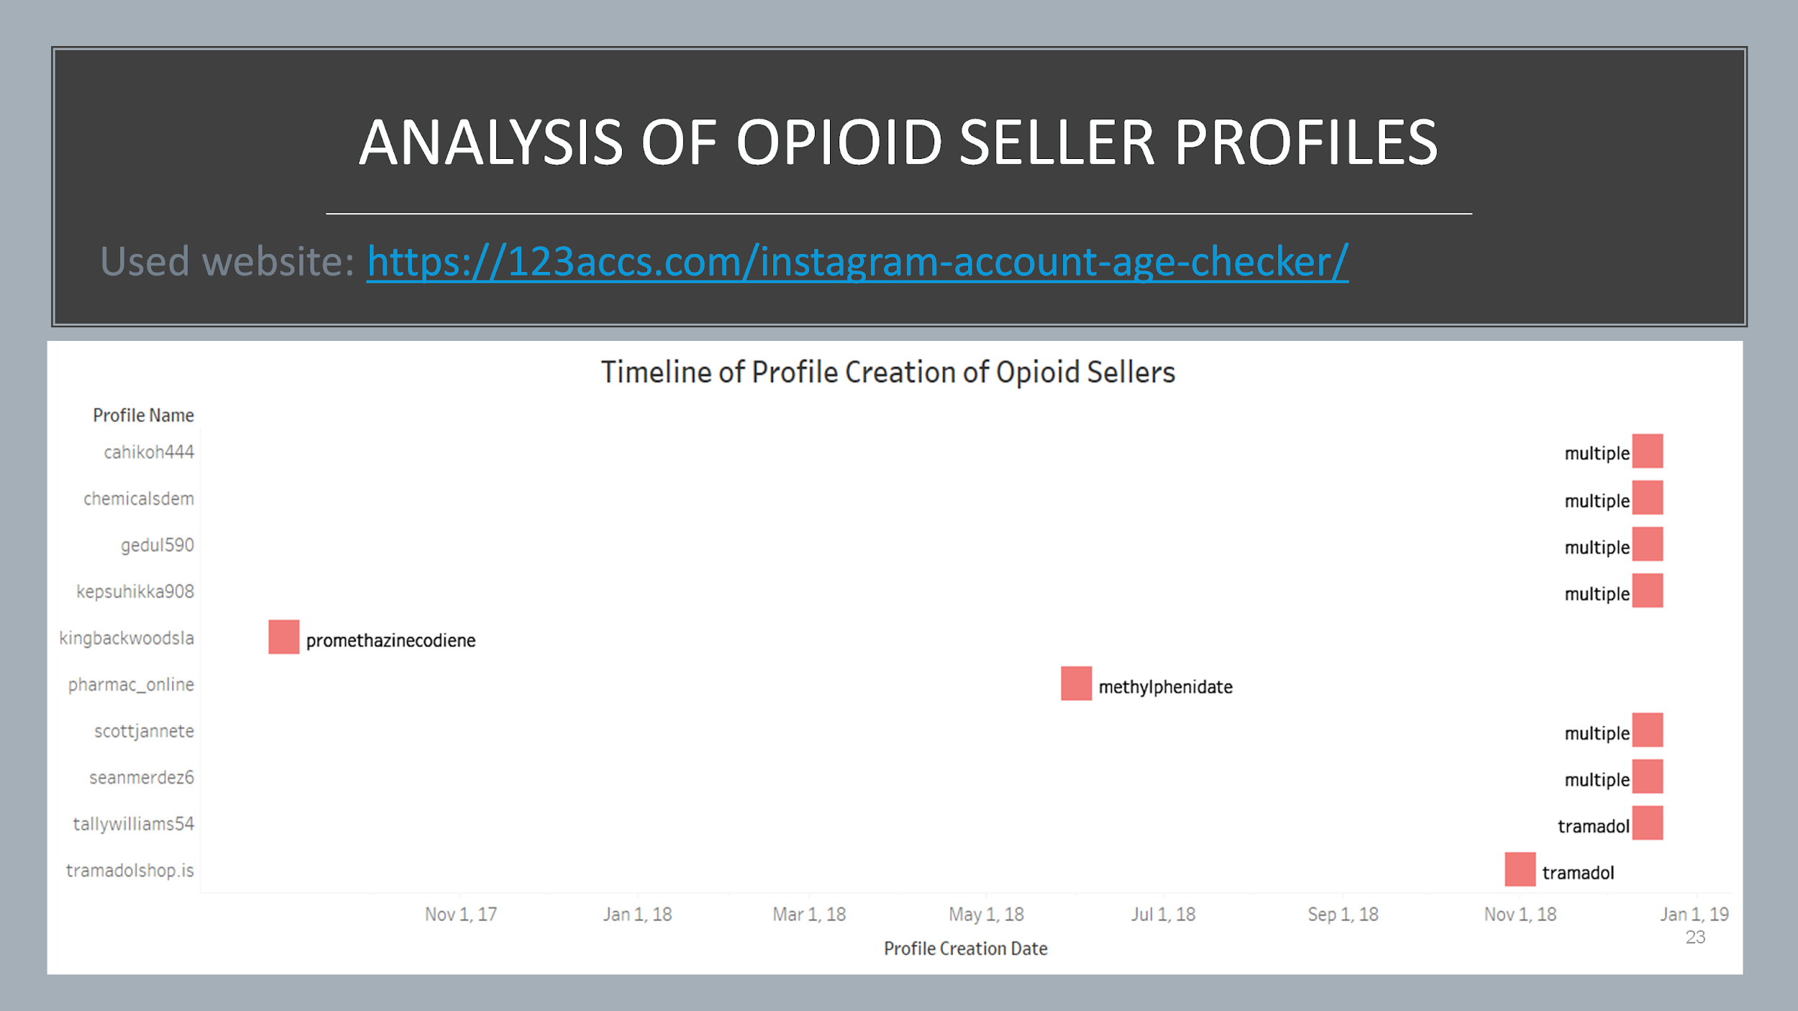

The following are the example of Opioid Posts and screenshots of the profiles of Sellers:

Figure 12. Posts of Opioid Sellers

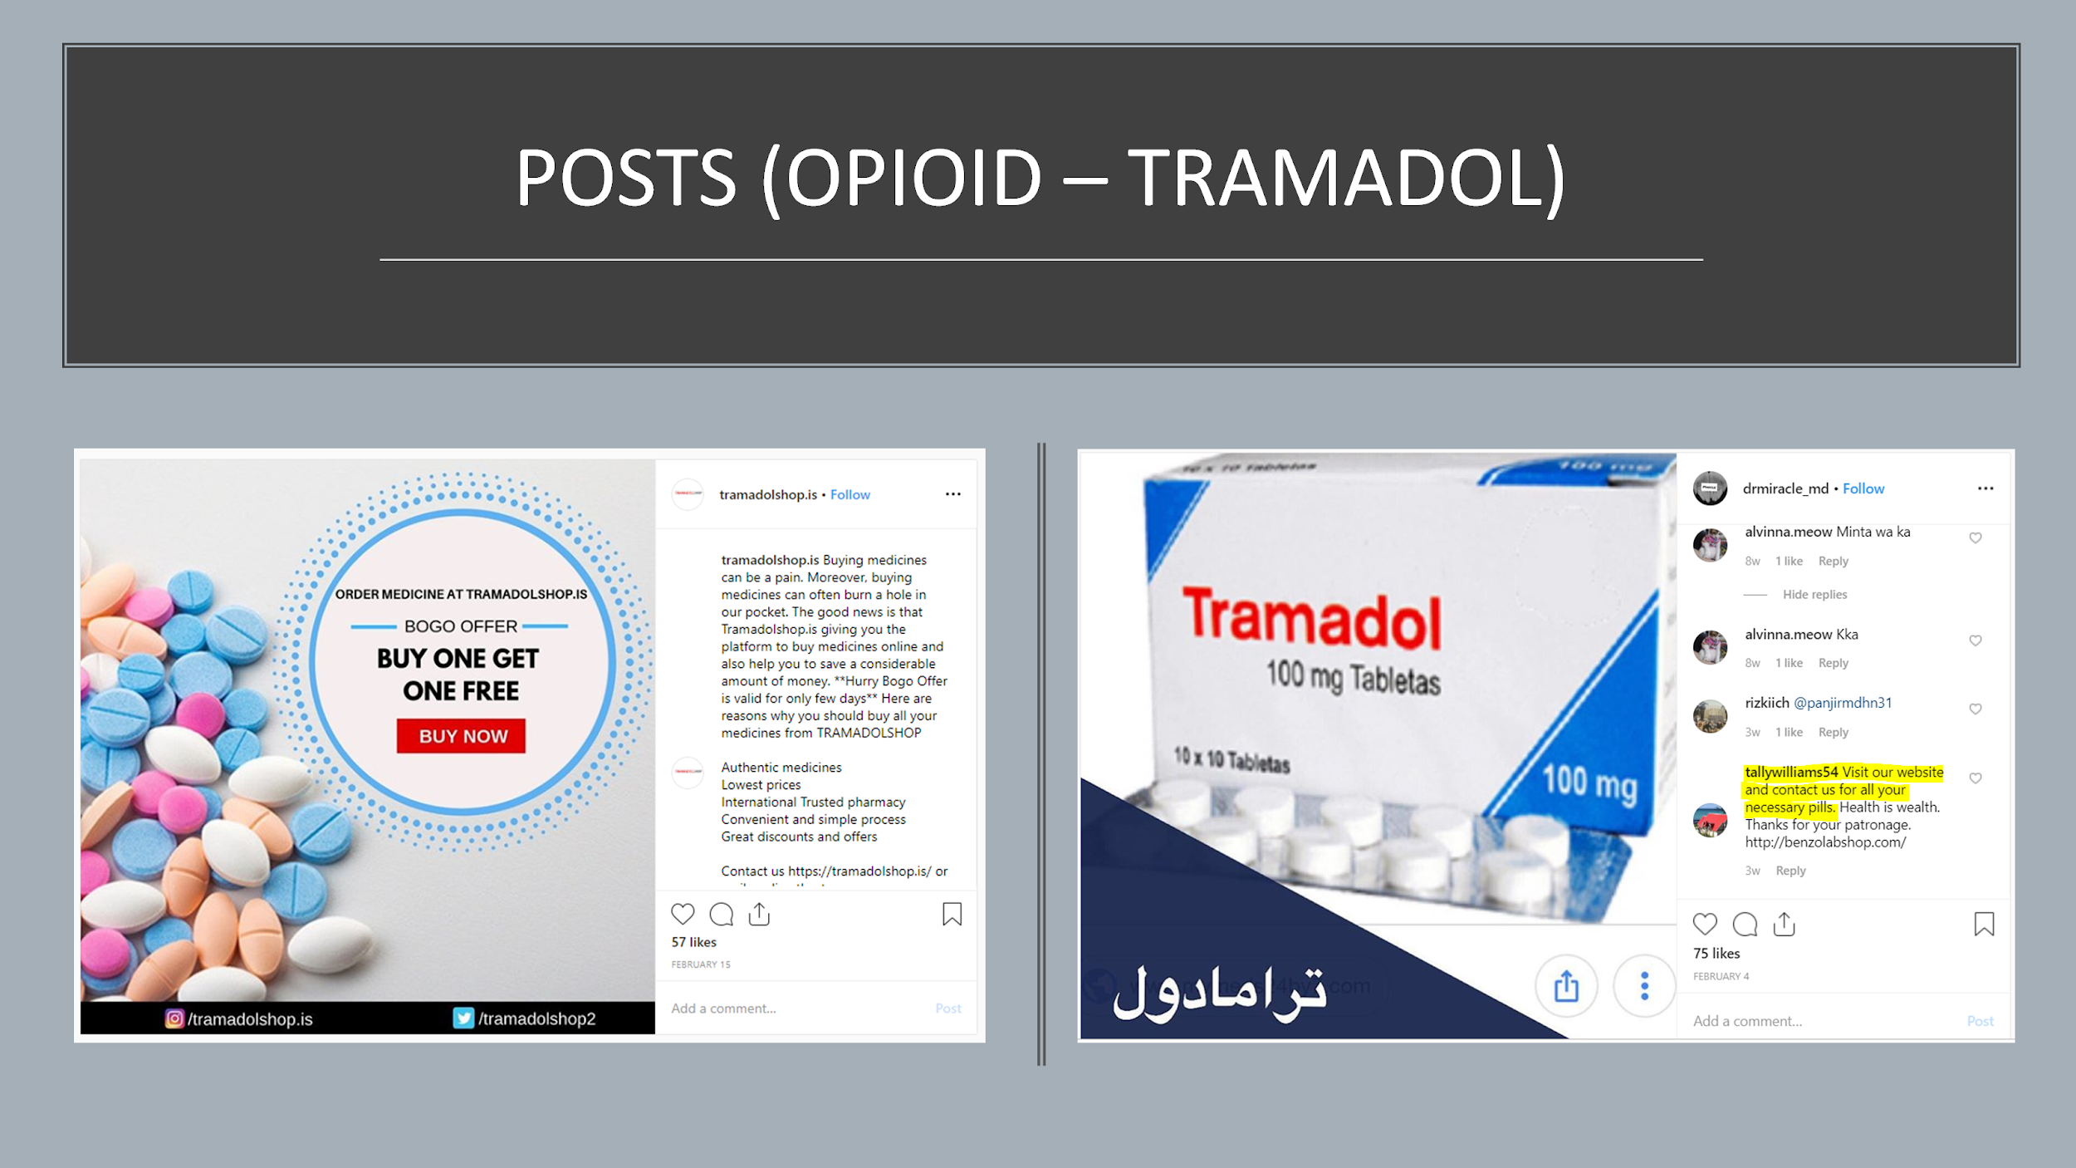

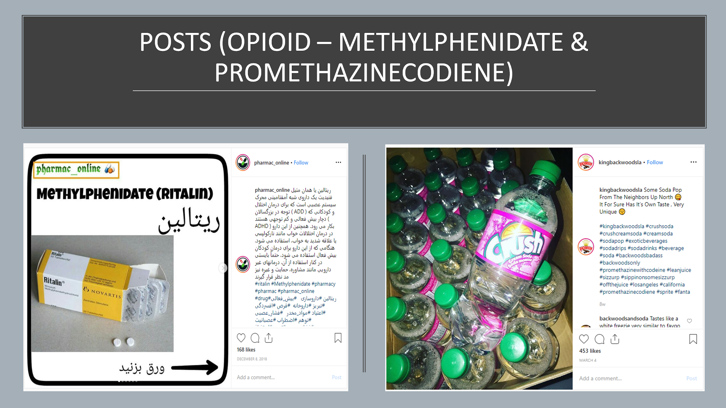

We found a particular use case below where a consumer has posted a content related to opioid which has been commented by 5 to 6 sellers in the same post. These are those sellers who create new fake profiles whenever they want to sell something and do not post but just comment.

Figure 13. Posts where Opioid Sellers have commented

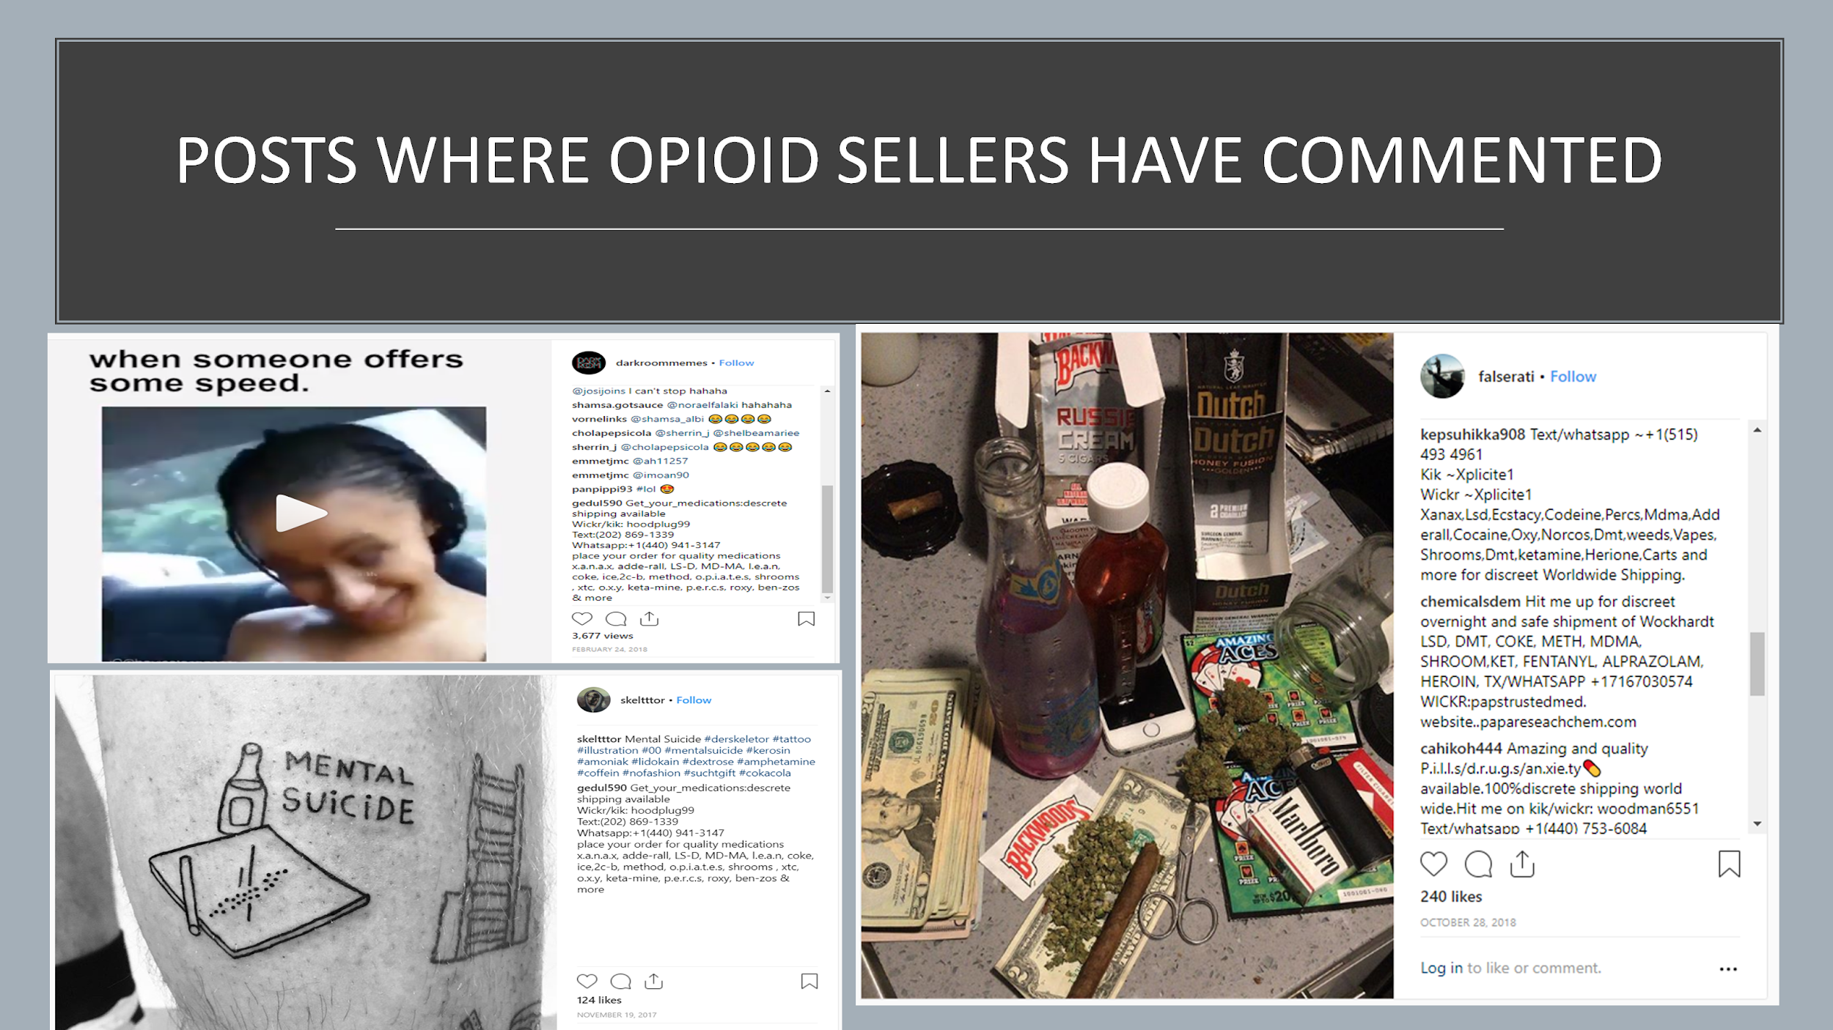

As we can see below from the profiles of sellers that a few of them have provided their contact details in their bio. The sellers who do not post but just comment do not have anything in their bio.

Figure 14. Profiles of Opioid Sellers

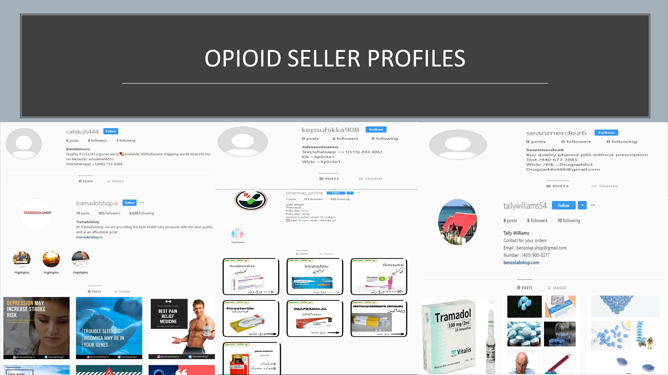

The following screenshot shows the websites of the two sellers who are selling Tramadol and other opioids.

Figure 15. Websites of Sellers

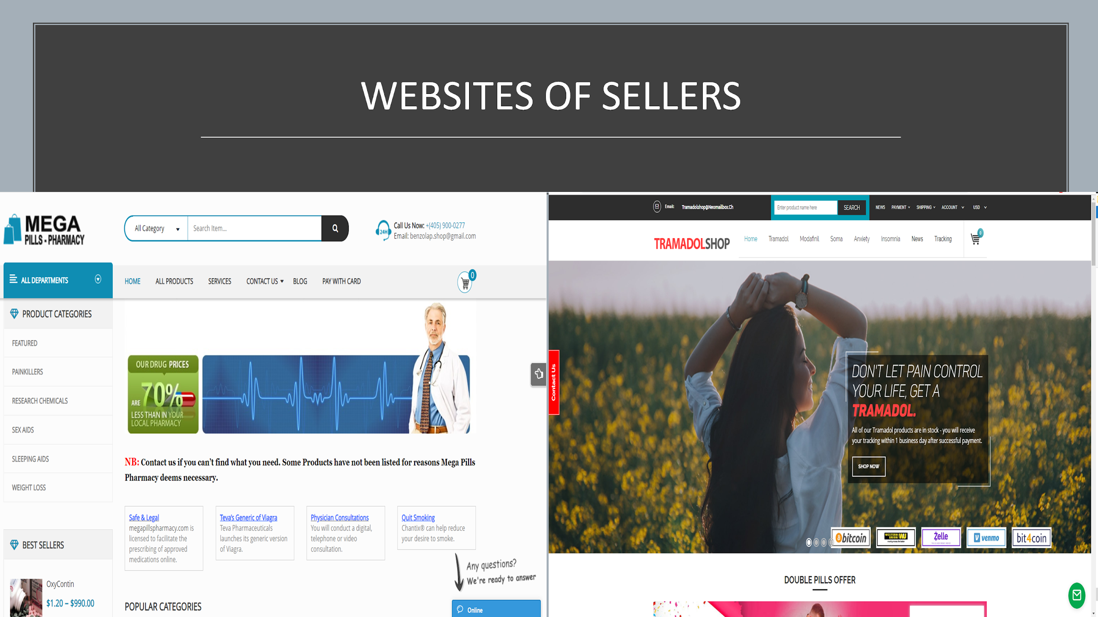

### Analysis of Marijuana Selling Posts

Figure 16. Distribution & Posts Count of Marijuana Sellers

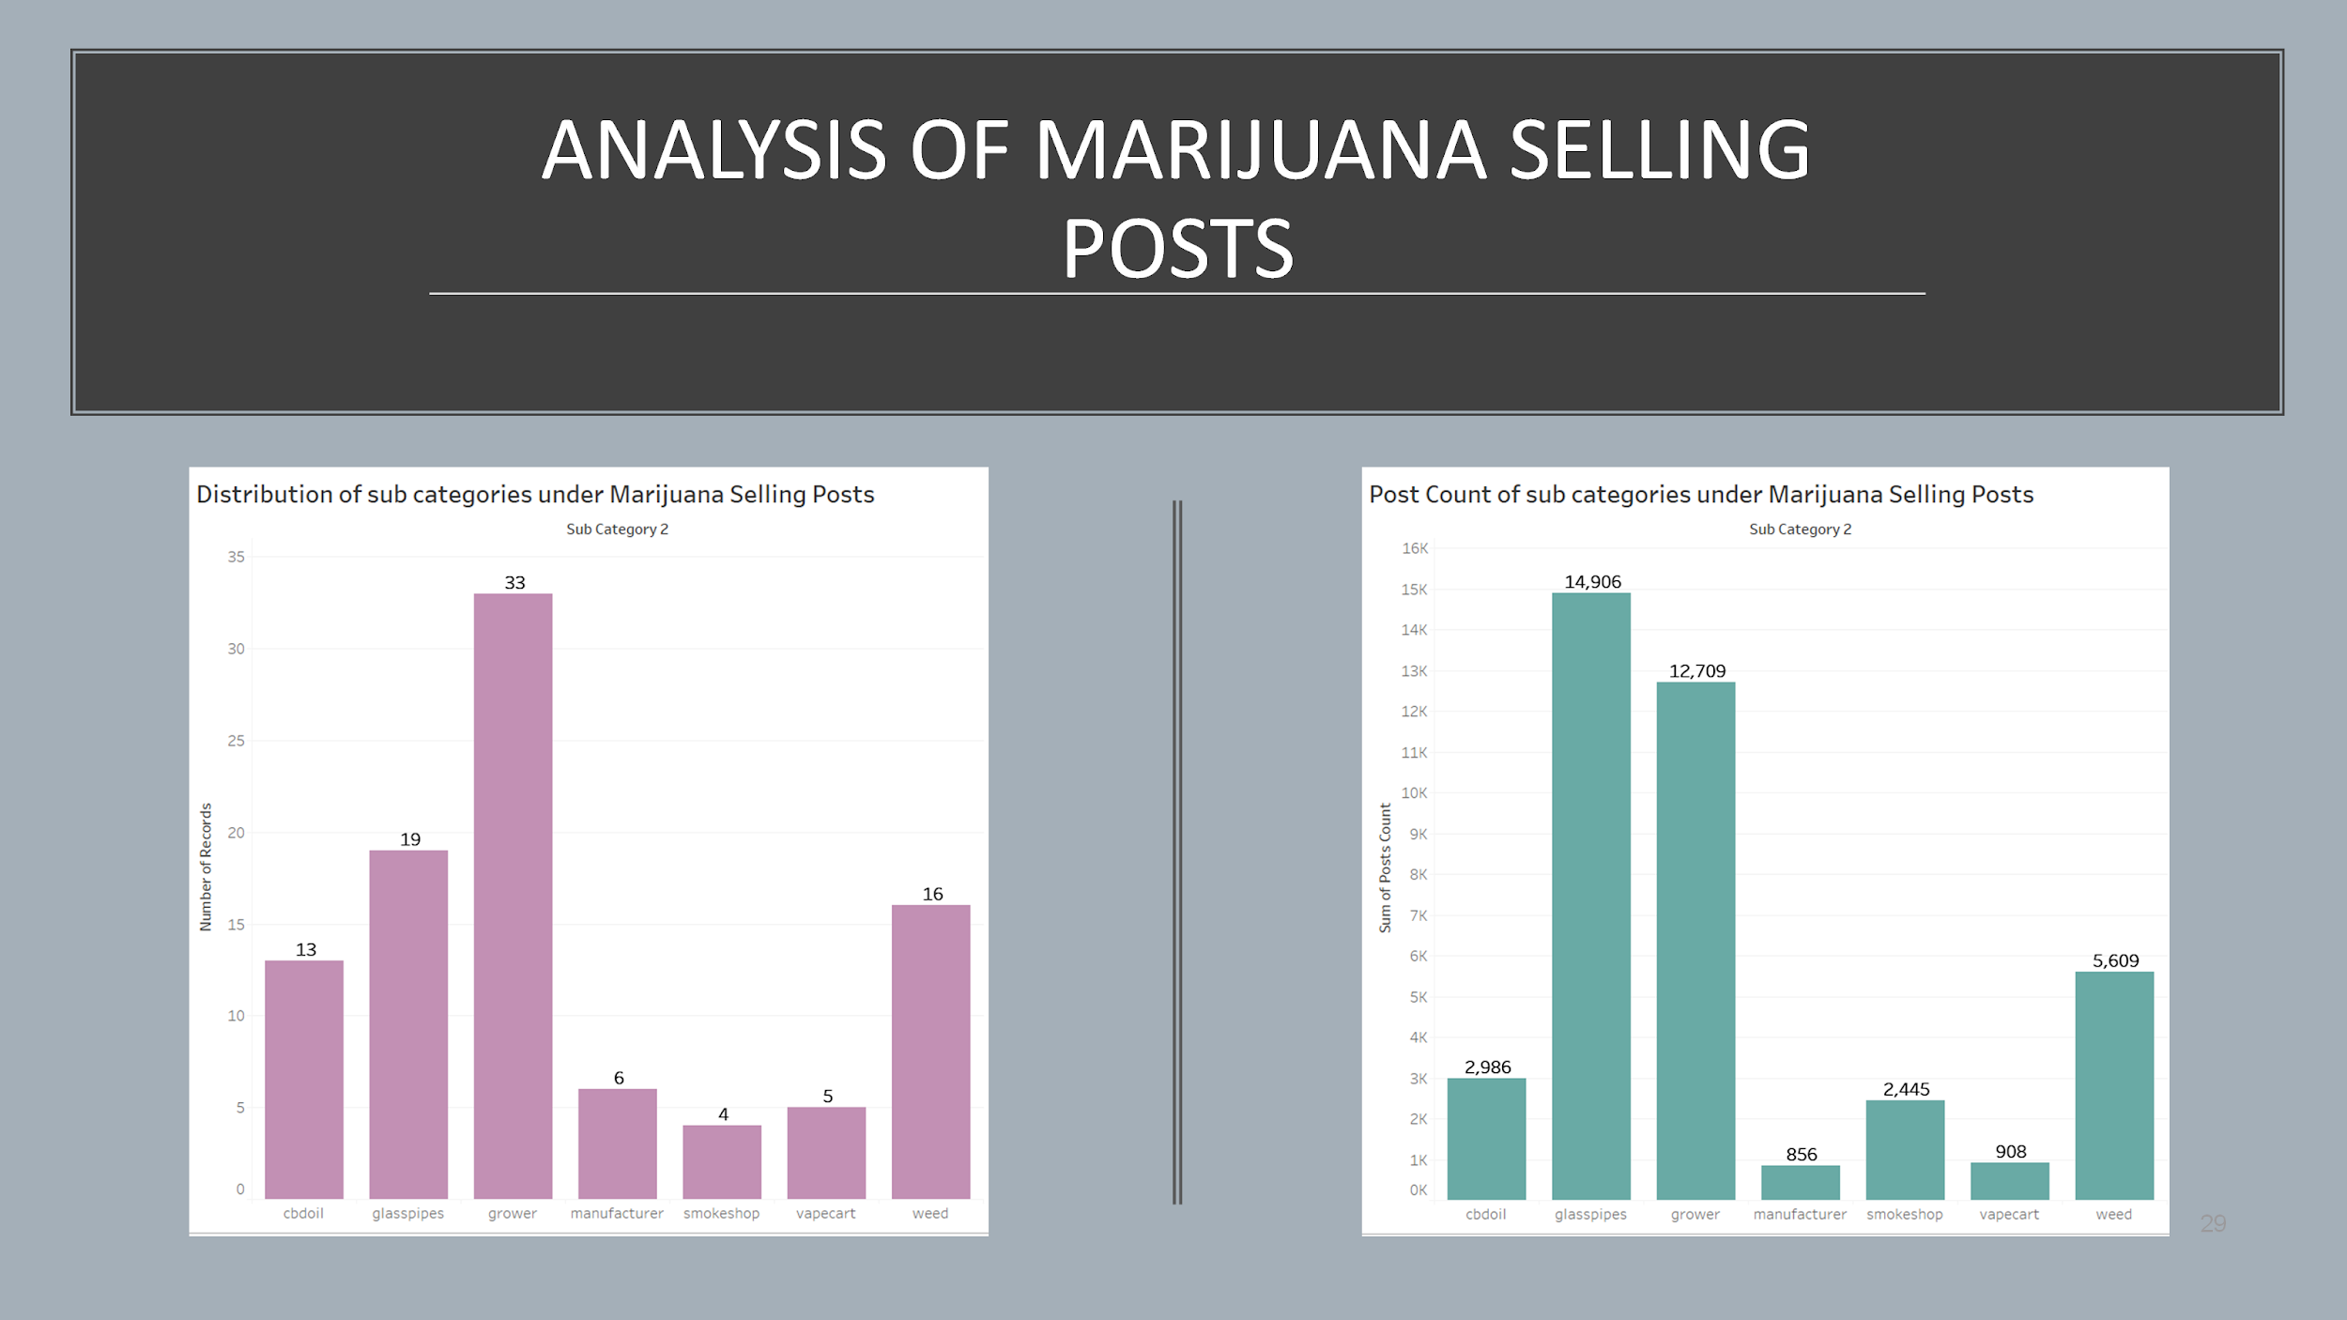

The top-selling posts were from the marijuana growers, followed by the weed(marijuana) sellers and then the sellers of glasspipes(accessory for smoking) and it was followed by sellers of medical cbd oil. On the other hand, sellers of glasspipes had the most postCounts, followed by growers and the weed sellers. The insights we got from these two histograms were:

* Sellers who usually grow marijuana promote others to grow the same on their own
* The accessories sellers use photo-sharing social media apps like Instagram a lot to advertise their collection of items that they are selling.

We can find from the below chart that growers have the largest followingCount followed by glasspipes sellers. On the other hand, it is vice versa for the followersCount. The insight that we get from this chart is that a lot of marijuana consumers follow sellers who are selling glasspipes and who grow marijuana.

Figure 17. Followers Count & Following Count Distribution of Marijuana Sellers

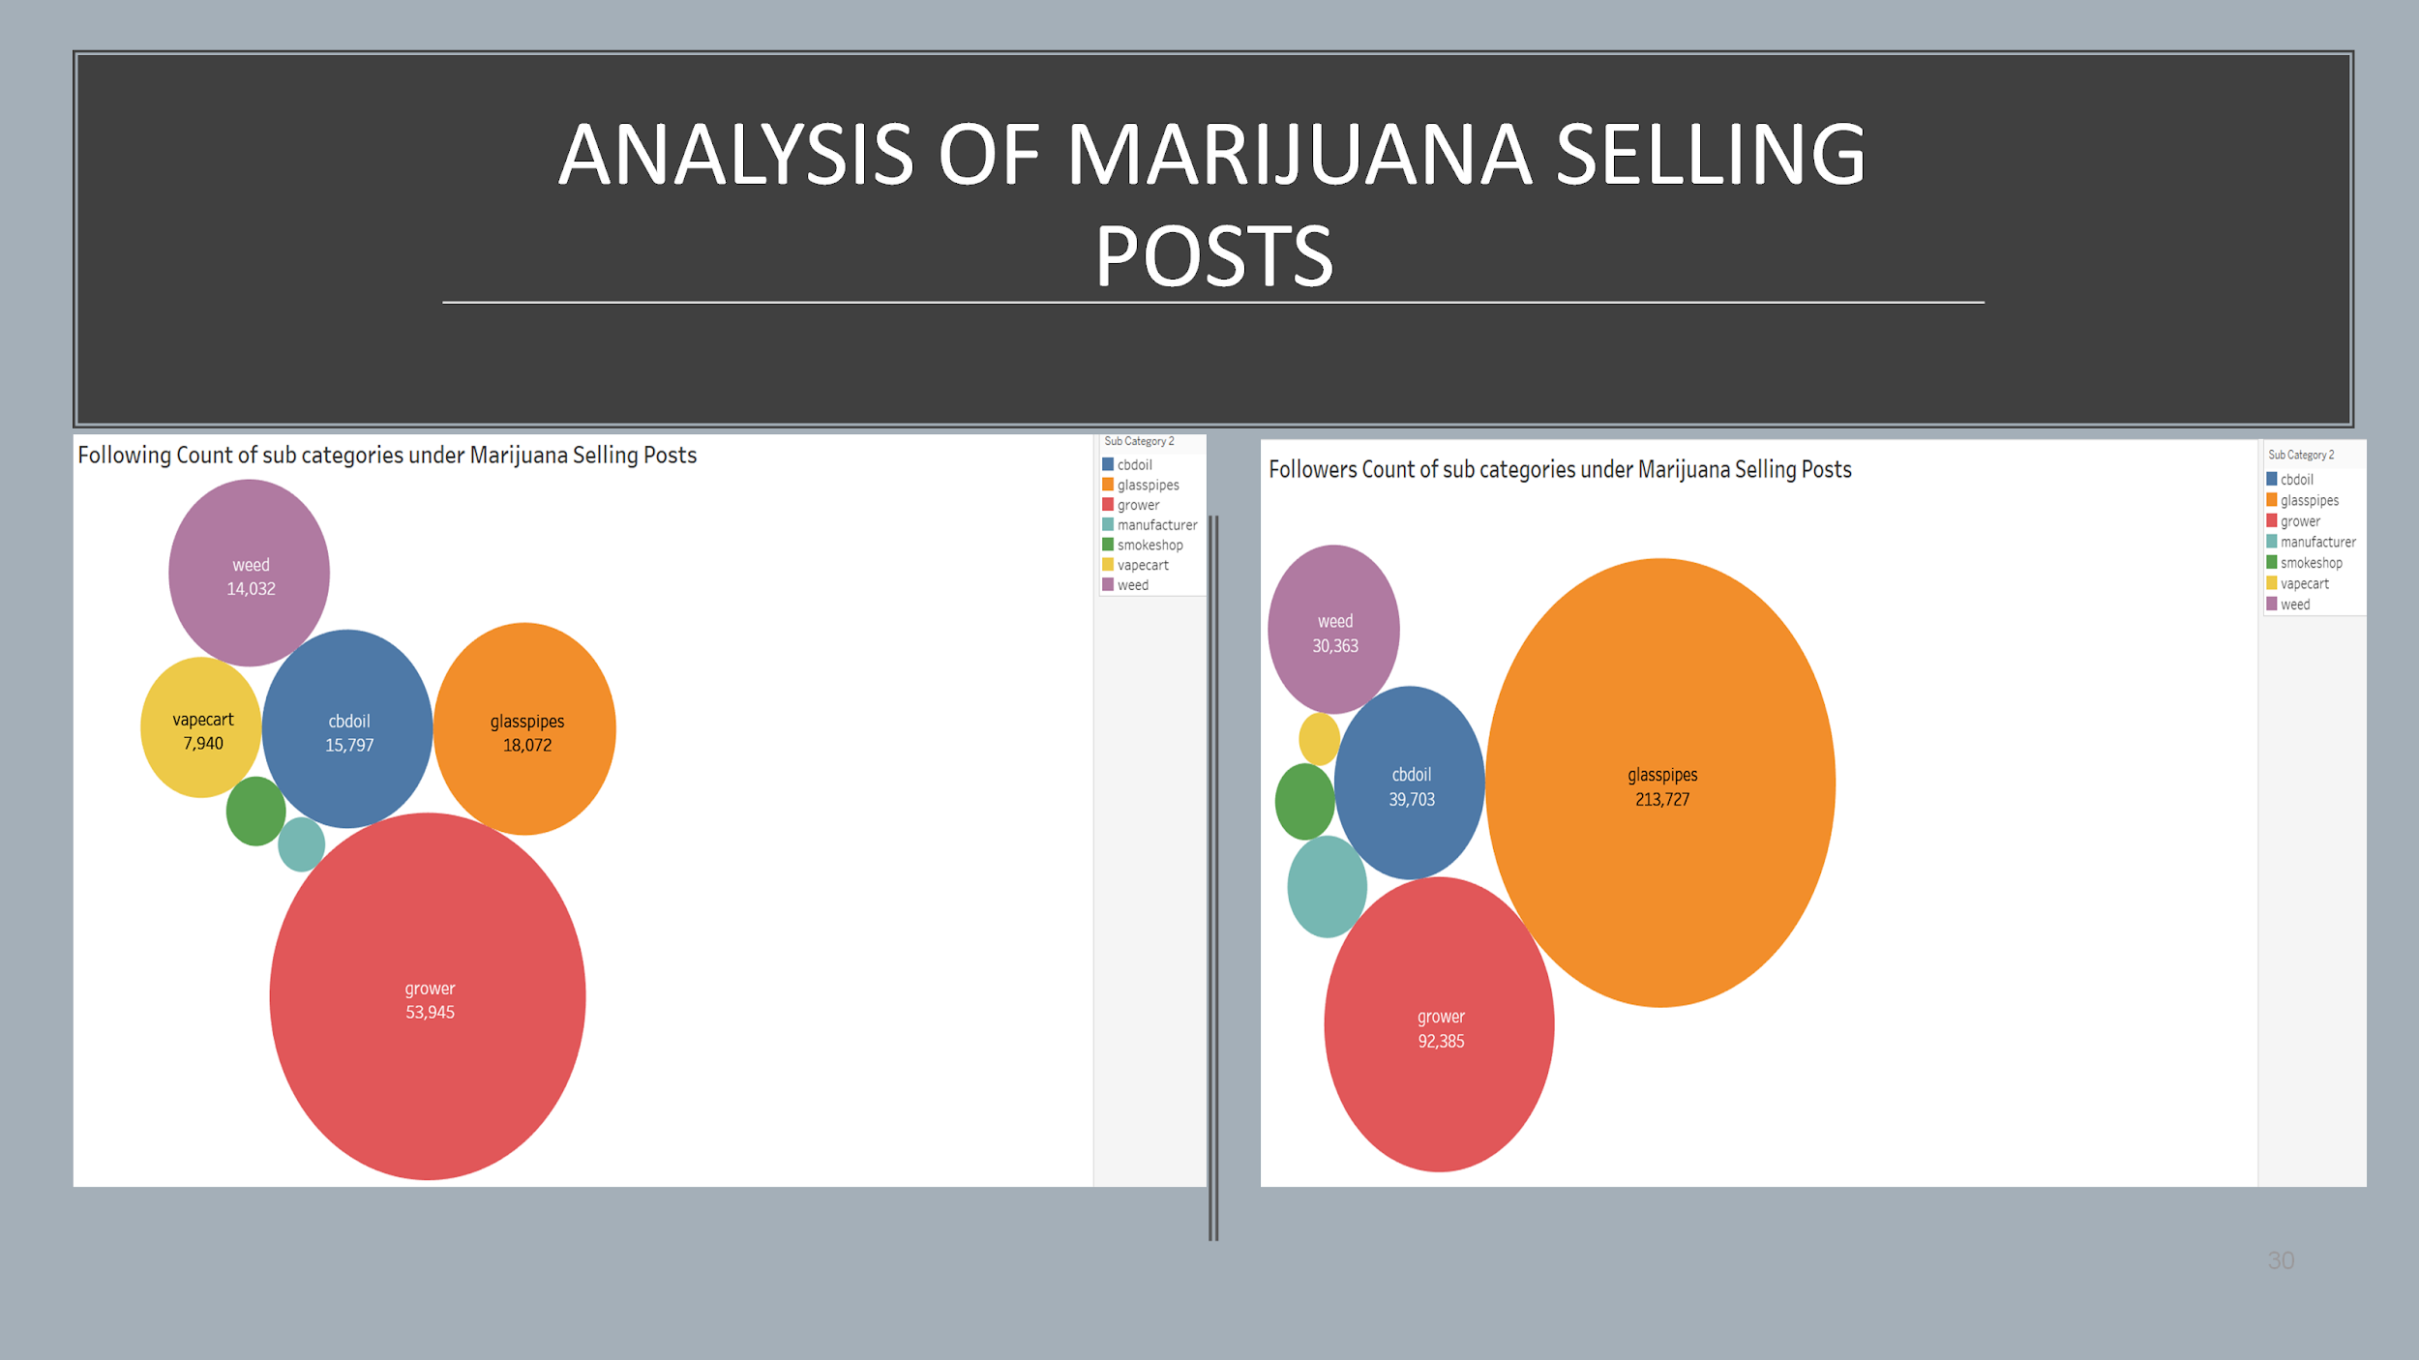

The following are the posts of marijuana sellers. An example has been provided for each subcategory under marijuana selling posts:

Figure 18. Posts of Marijuana Sellers

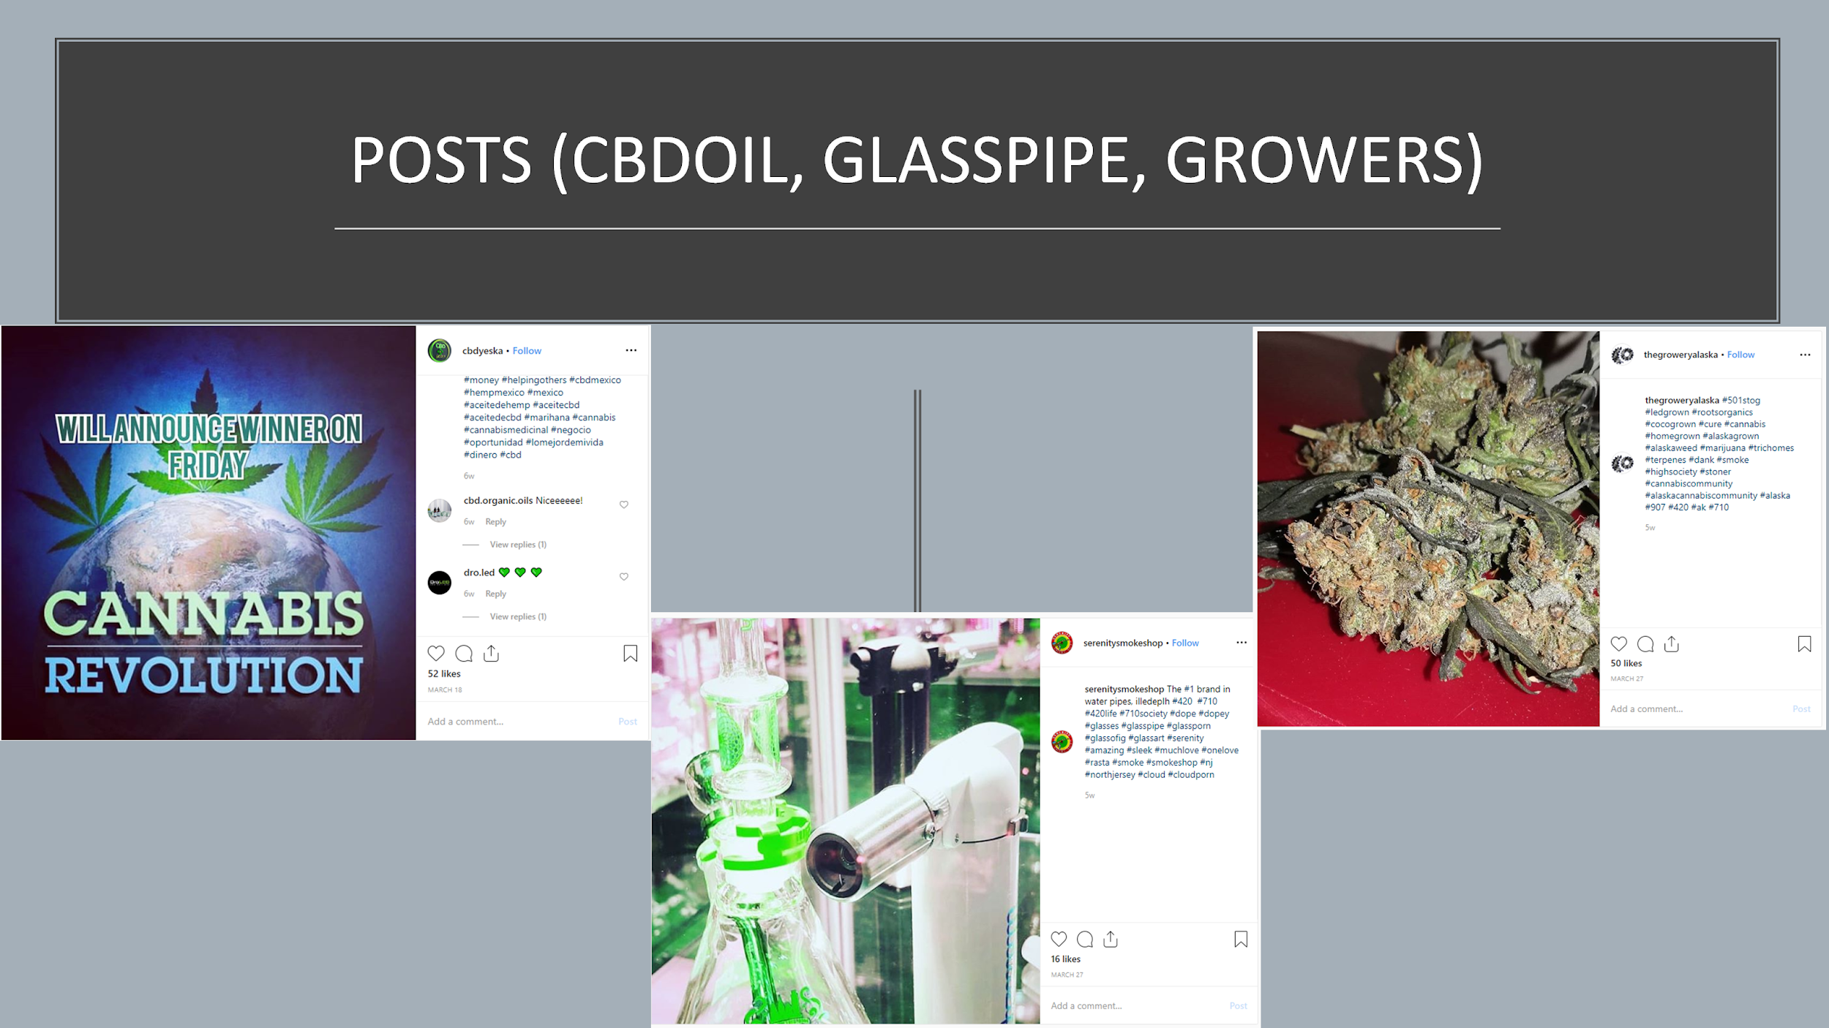

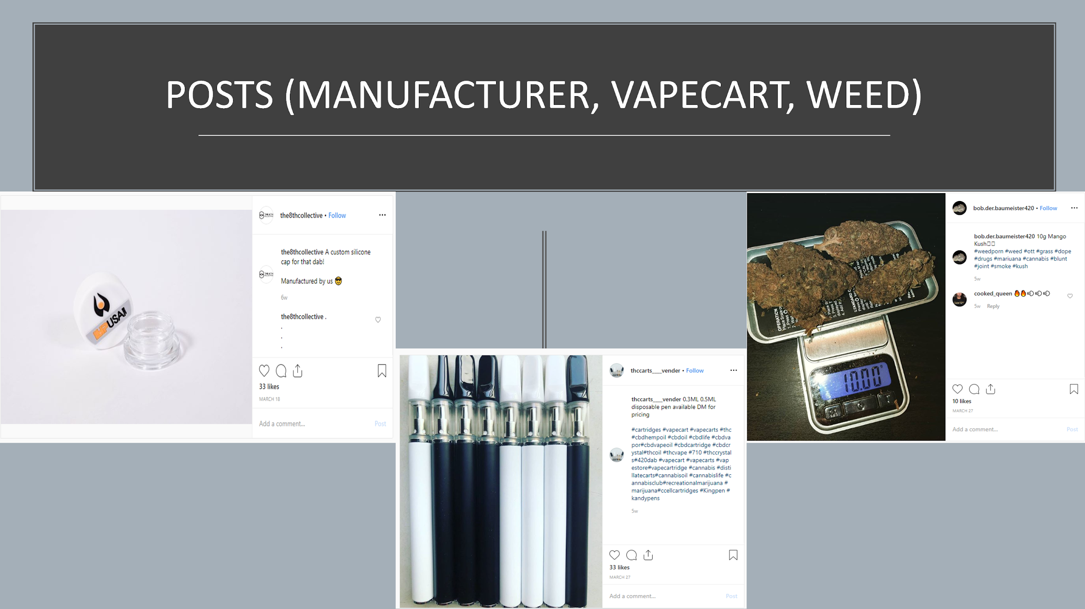

The following are the screenshots of the seller profiles of marijuana under each category:

Figure 19. Seller Profiles of Marijuana

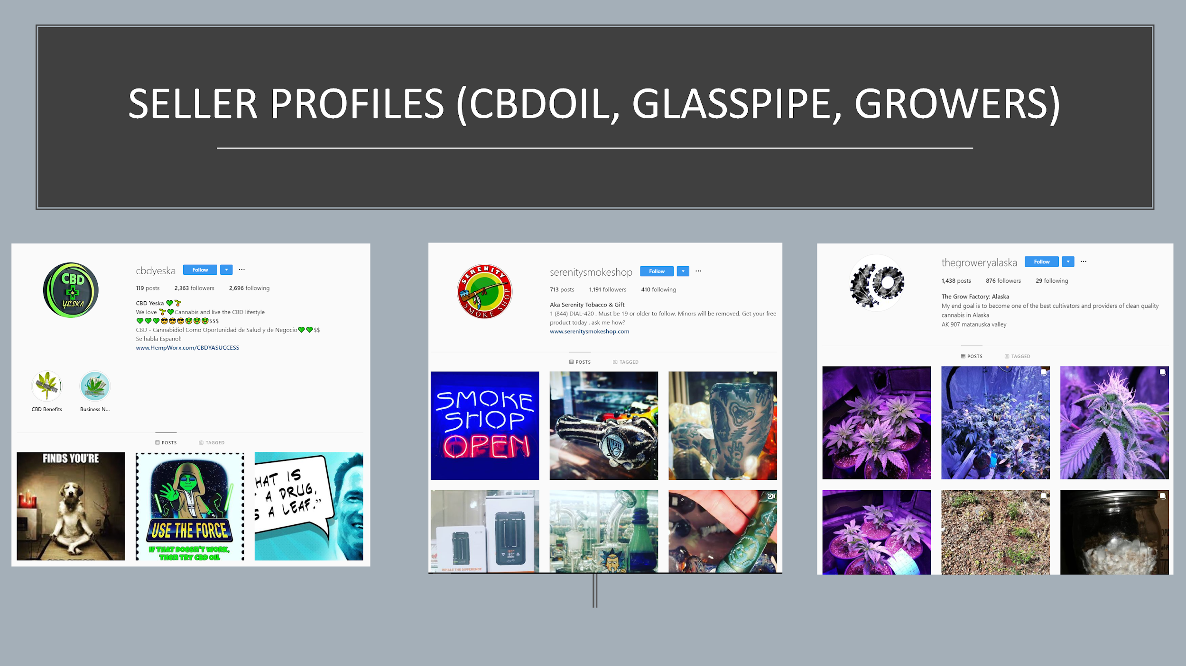

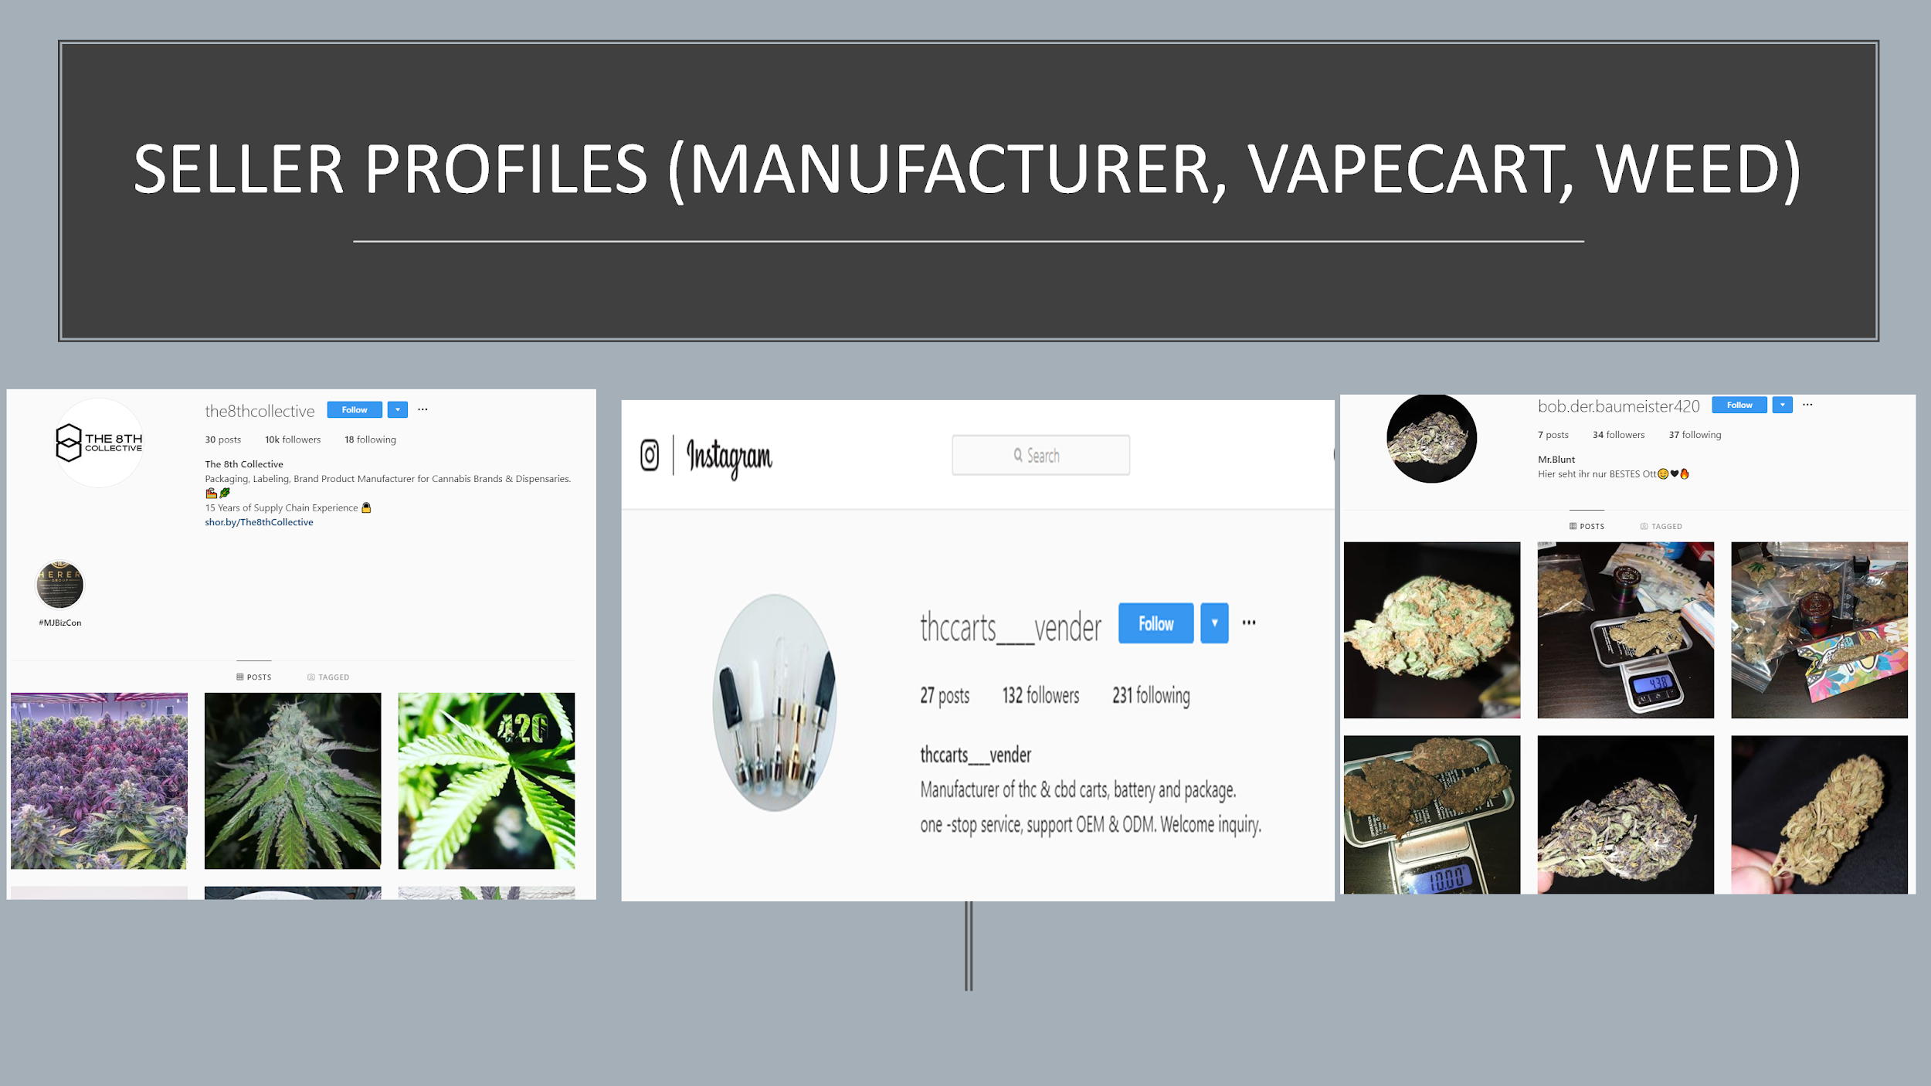

### Insights of Opioid Vs Marijuana posts

From the training data sample of 643 relevant texts, out of 116 Selling posts among this 643, almost 90% of those were marijuana selling posts and only close to 10% of them were opioid selling posts. If we compare the differences of characteristics between the sellers of opioid and marijuana on Instagram, we can find that:

* Marijuana sellers tend to have a greater number of postCounts and post frequently than opioid sellers since it is understood that selling and consuming marijuana and its related products are legal in a few States in the US.
* The profiles of marijuana sellers look original and they tend to have more followersCount and they have more followingCount as well whereas opioid sellers create fake profiles now and then and comment on lots of opioid-related posts rather than creating a post so that their contact can reach to a larger audience.
* Another important reason behind the opioid sellers creating fake profiles is that Instagram has started removing posts and comments related to opioid in a timely manner regularly since October 2018 when opioid epidemic became critical in the US.
* This was an important reason why a lot of hashtags related to opioid keywords did not return any content from the API.
* Also when Instagram finds a user trying to access opioid-related posts it tries to hide it from the particular user when logged into the account which we noticed when accessing a user post where we were able to see 5-6 sellers commented for that particular opioid post when we were not logged into Instagram.
* These challenges limited our collection of data related to opioid posts

## Analysis of Consumers

Figure 20. Distribution of Opioid Consumers

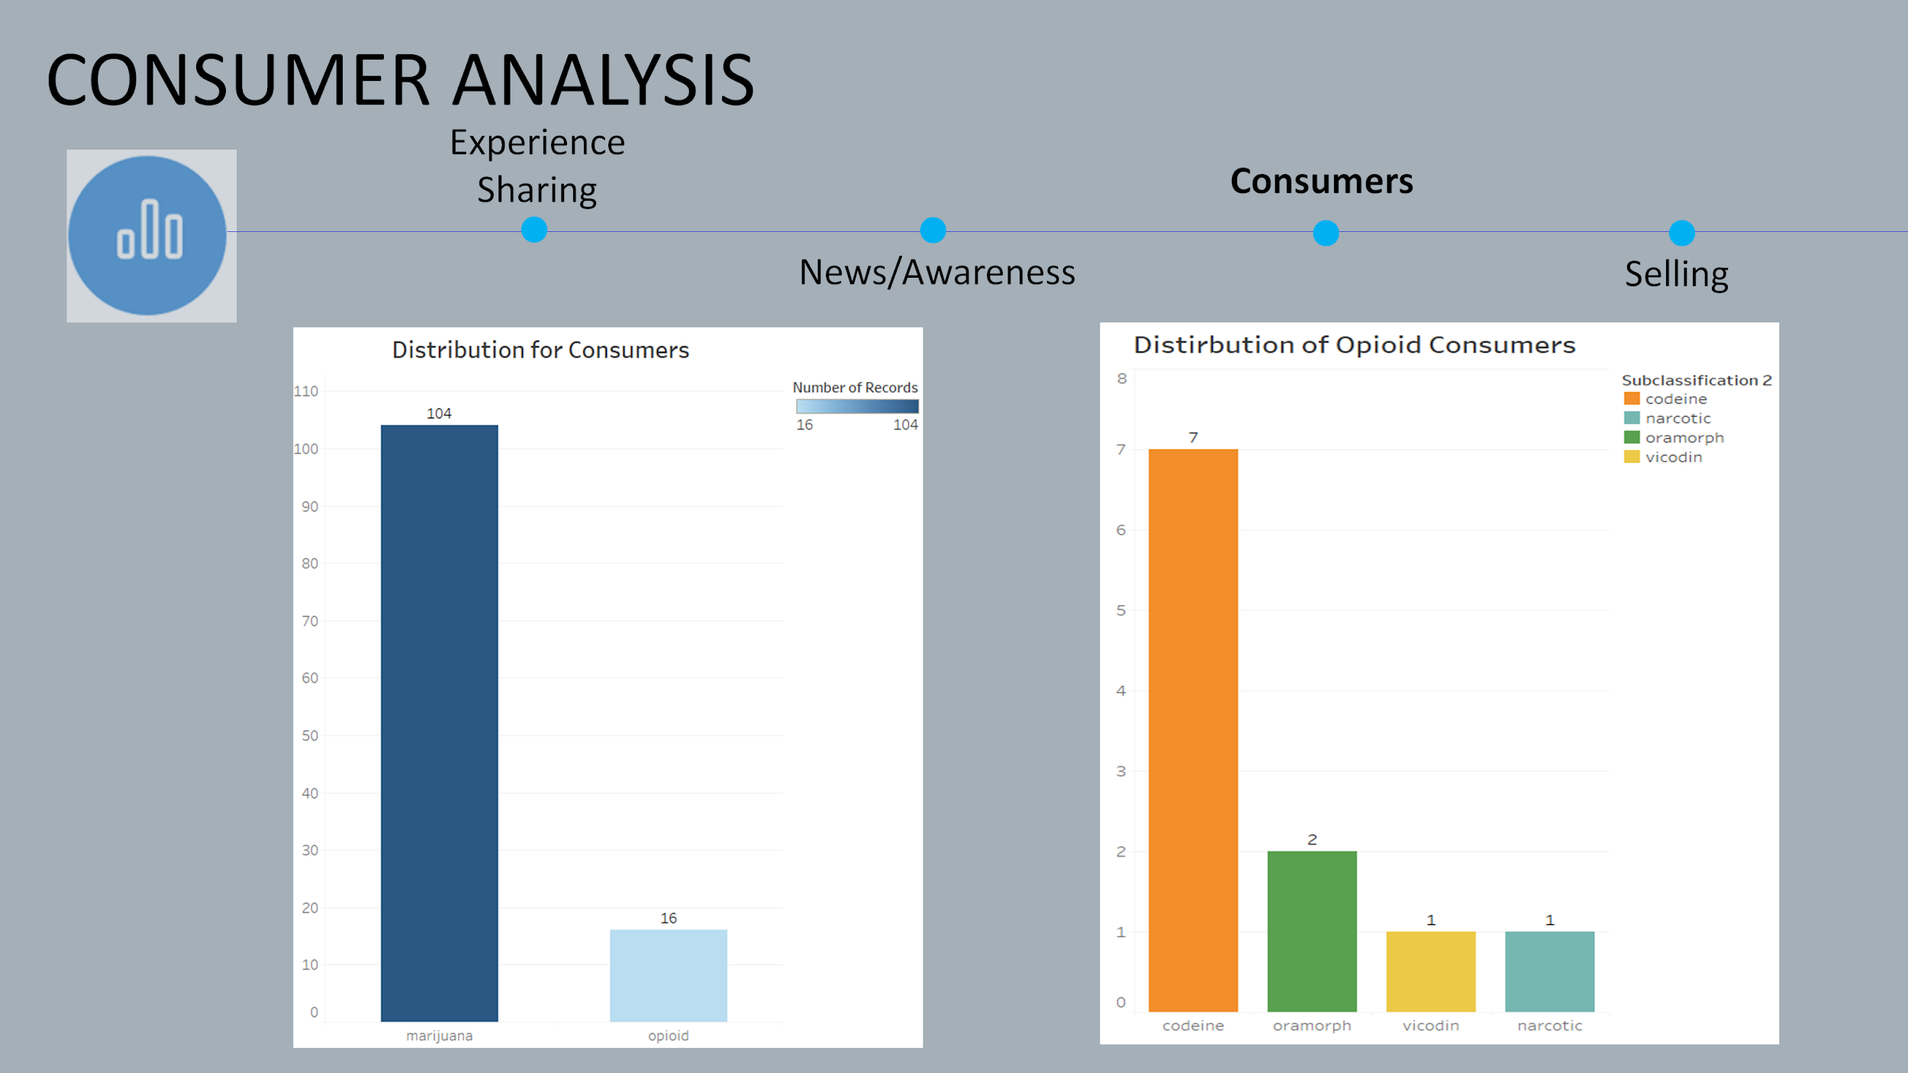

We can find the distribution of marijuana and opioid consumers to be skewed. Almost 85% of the posts are related to marijuana consumers and 15% of the posts are related to opioid consumers. Out of the opioid consumer posts, 7 posts were related to codeine.

Figure 21. Follower Count & Following Count of Opioid Consumers

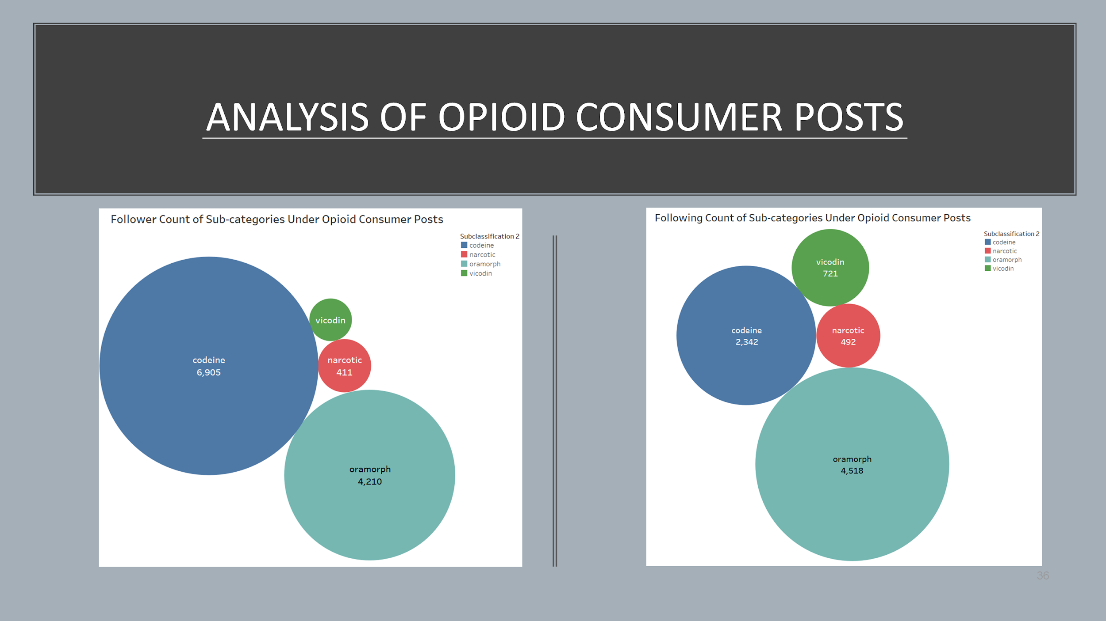

The Codeine consumers had the highest followerCount followed by Oramorph consumers. On the other hand, Oramorph consumers had the highest followingCount followed by Codeine consumers.

The following are the screenshots of posts of opioid and marijuana consumers:

Figure 22. Opioid & Marijuana Consumer Posts

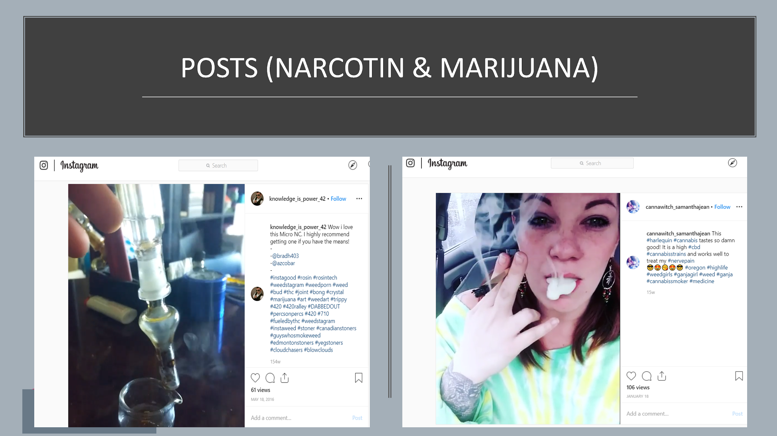

## Analysis of Experience Sharing

The Experience Sharing posts were manually subclassified into 8 subcategories:

* Addiction Recovery
* Medication Experience
* Opioid Addiction
* Weed/Cannabis Experience
* Injury/Pain
* Growing Cannabis
* Family Addiction Experience
* Others

Addiction recovery posts were the highest (more than 50%) under the subcategory of experience sharing. It was followed by medication sharing posts.

Figure 23. Distribution of Experience Sharing Posts

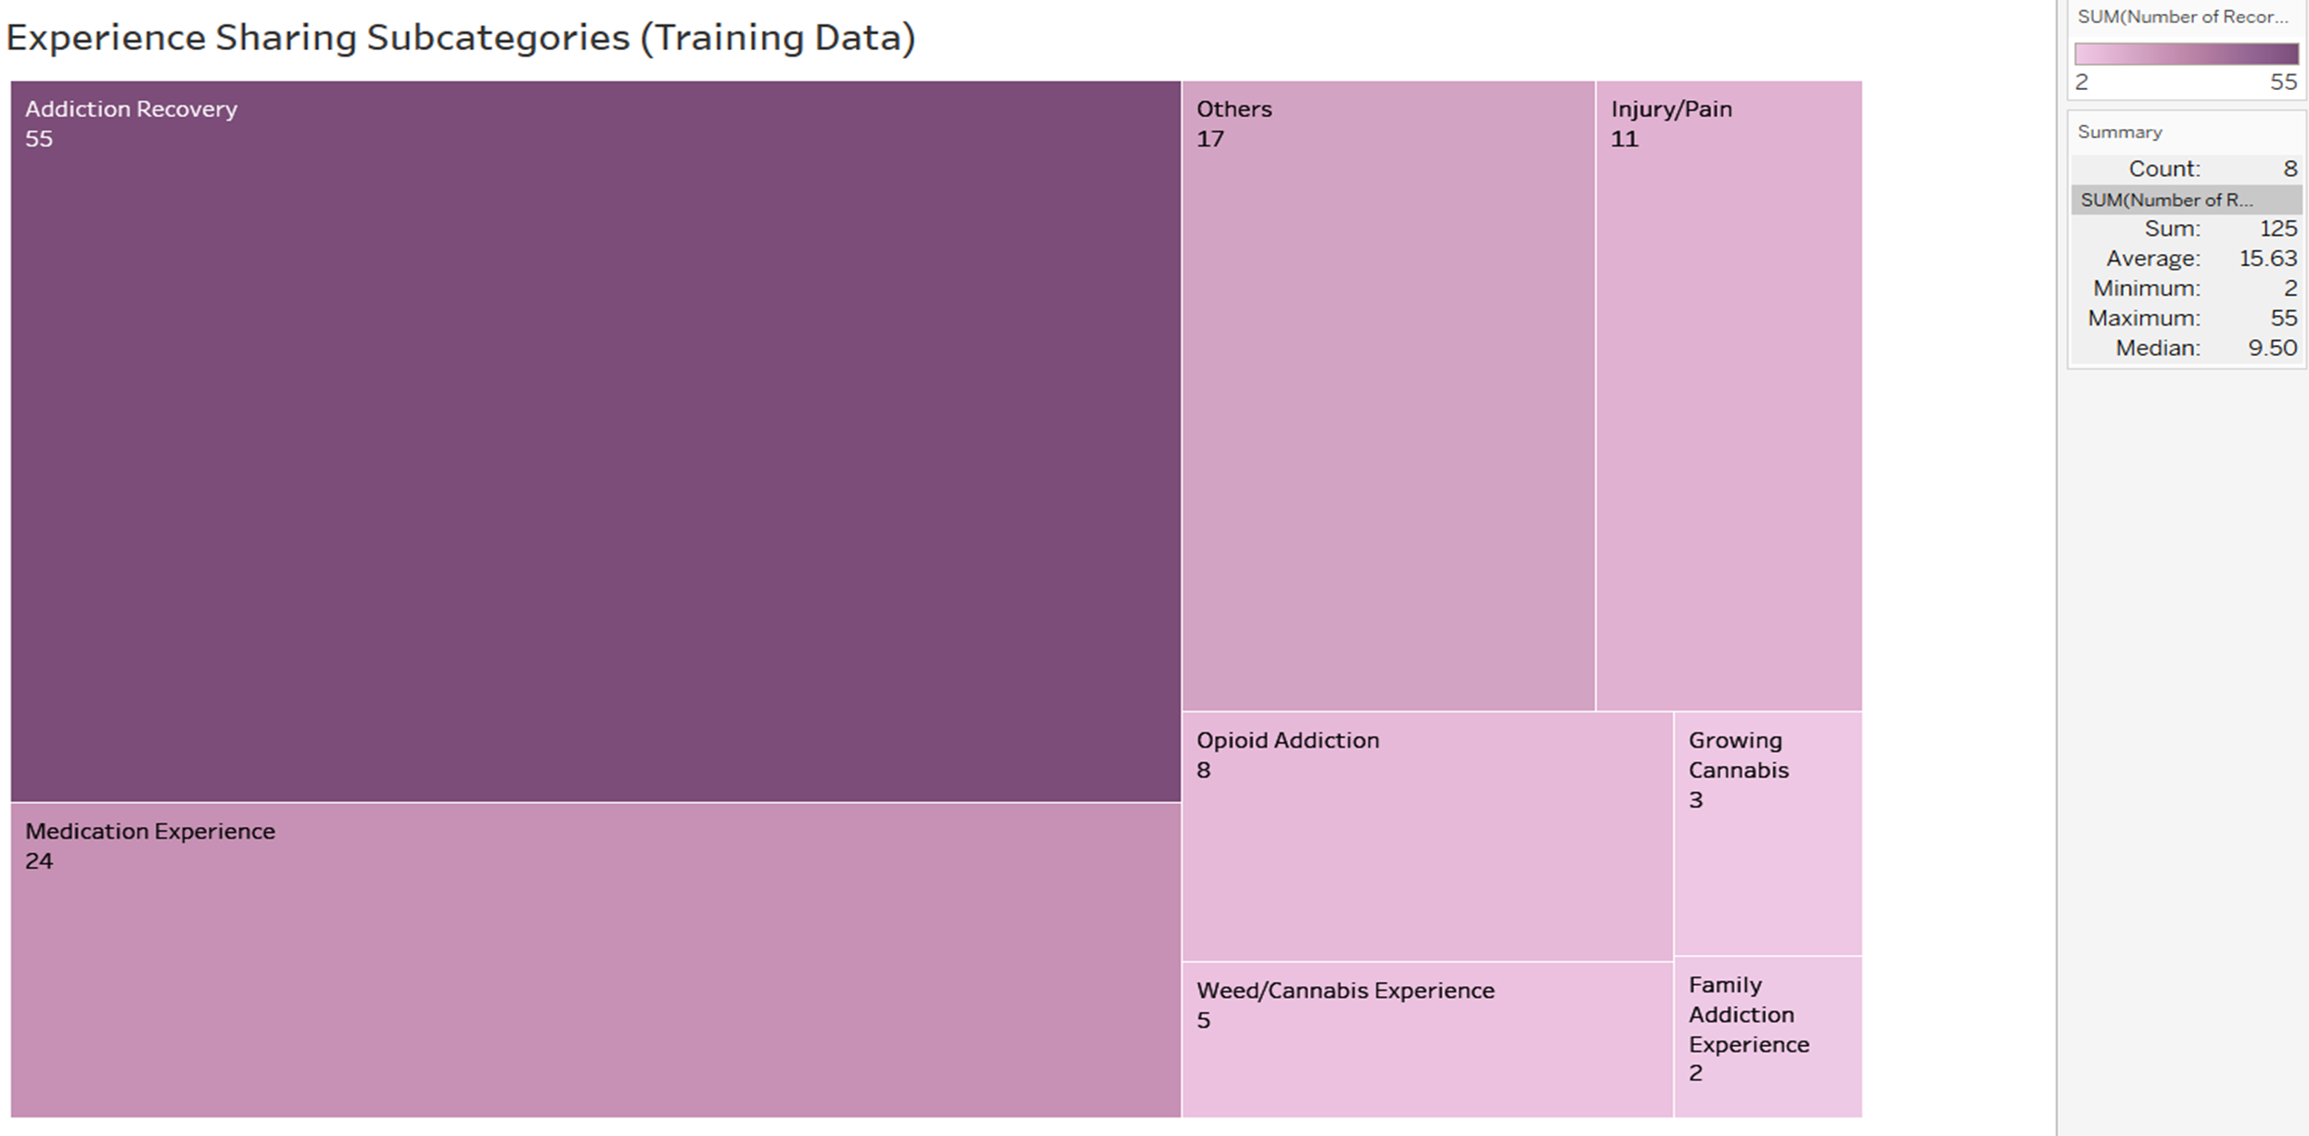

The following are the screenshots of Experience Sharing posts under each category:

Figure 24. Addiction Recovery Posts

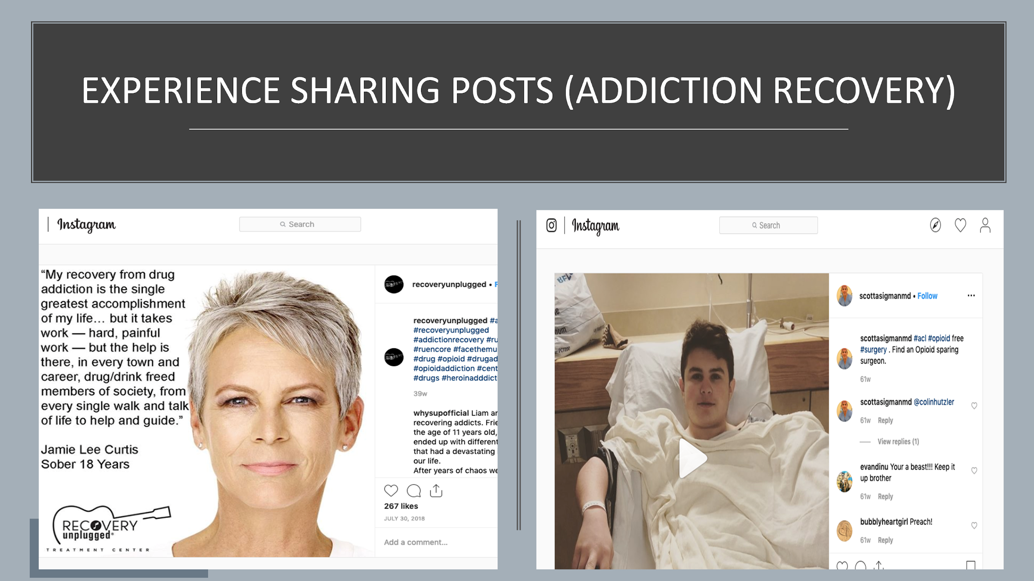

Figure 25. Opioid Addiction Posts

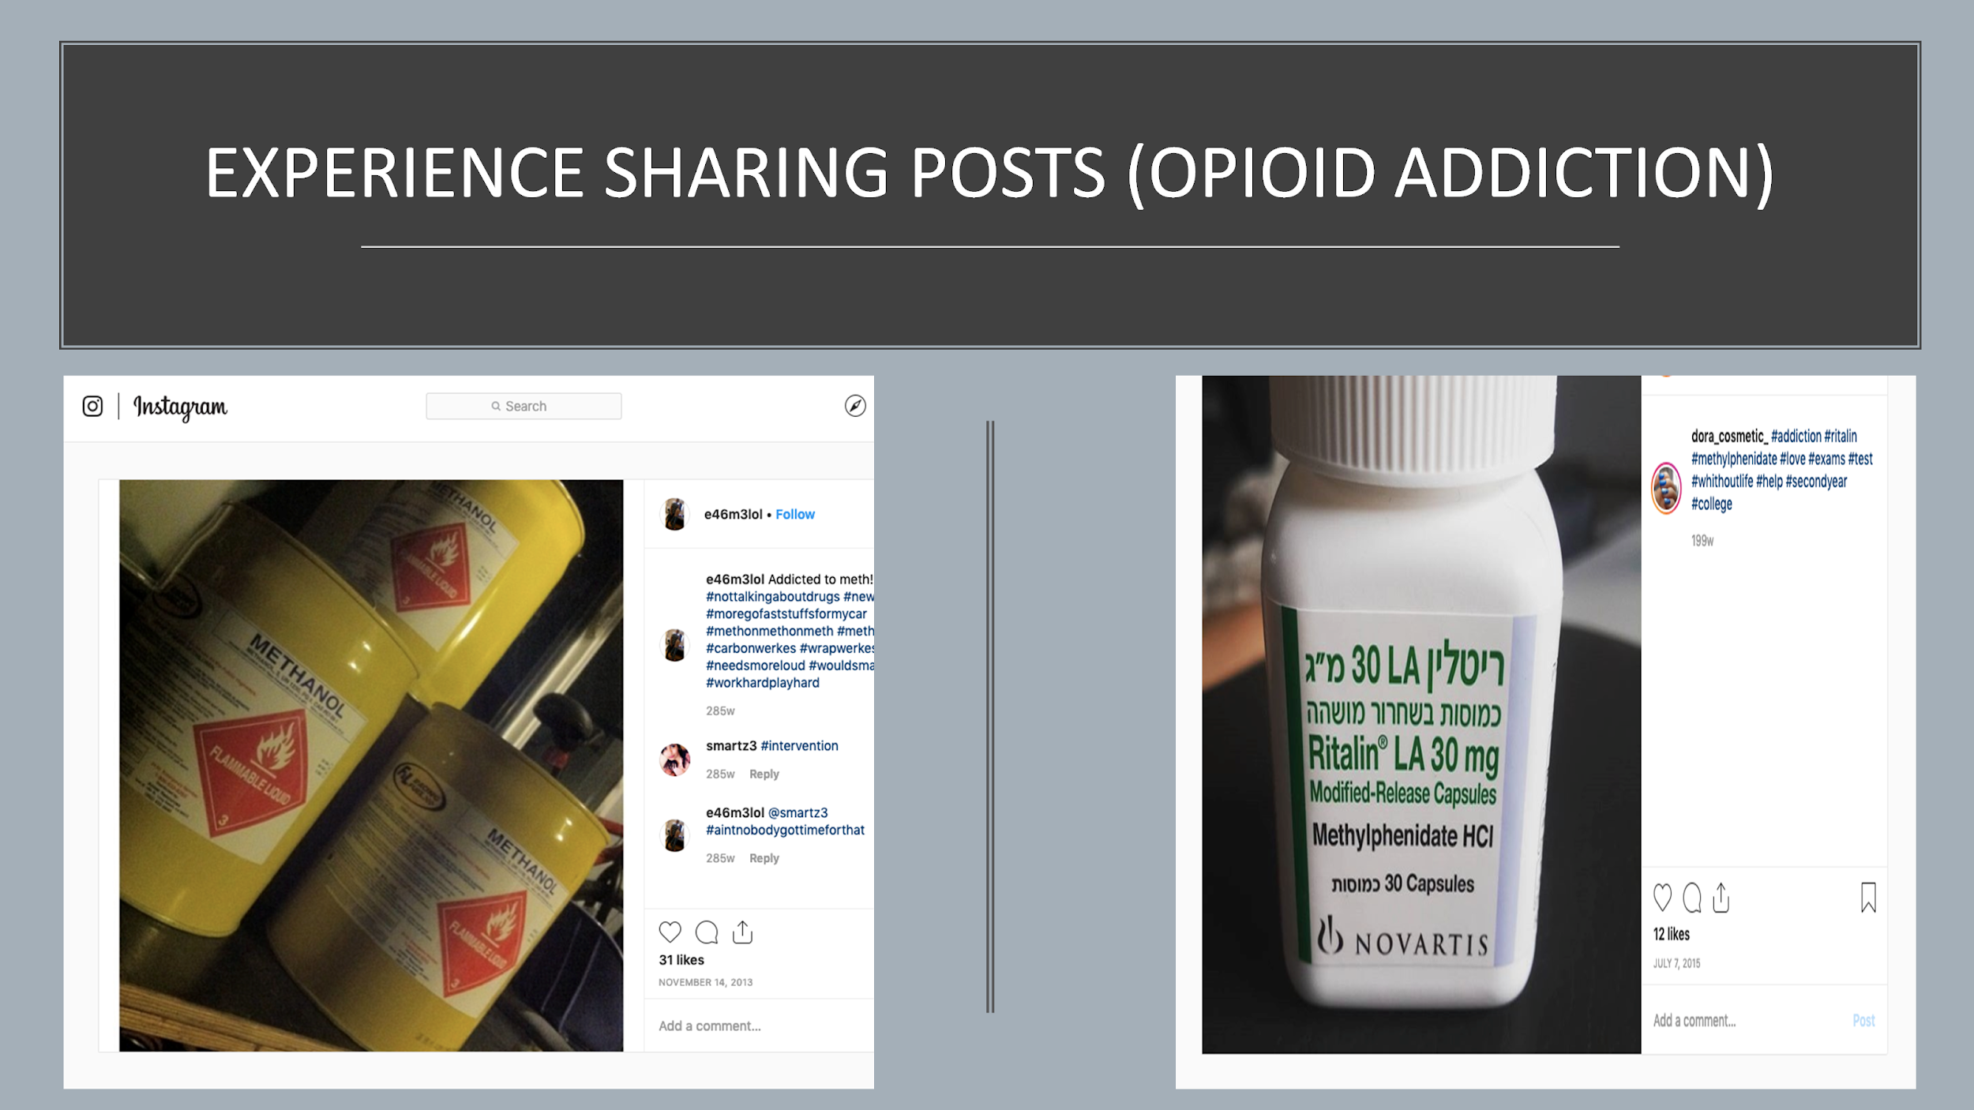

Figure 26. Medication Experience Posts

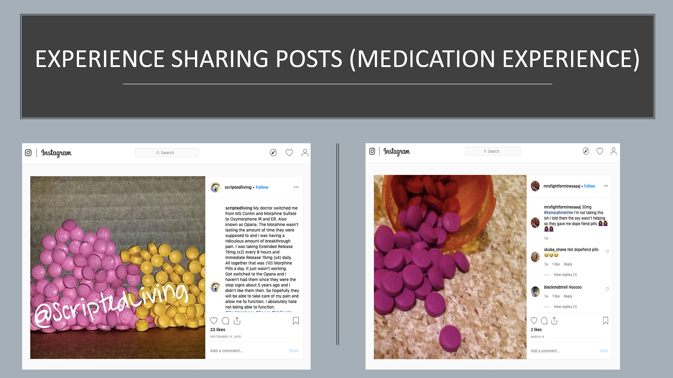

Figure 27. Family Addiction Experience Posts

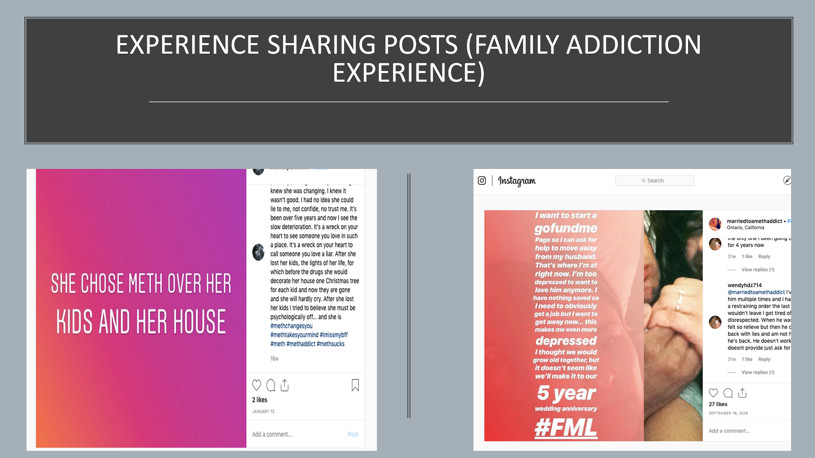

Figure 28. Weed/Cannabis Experience Posts

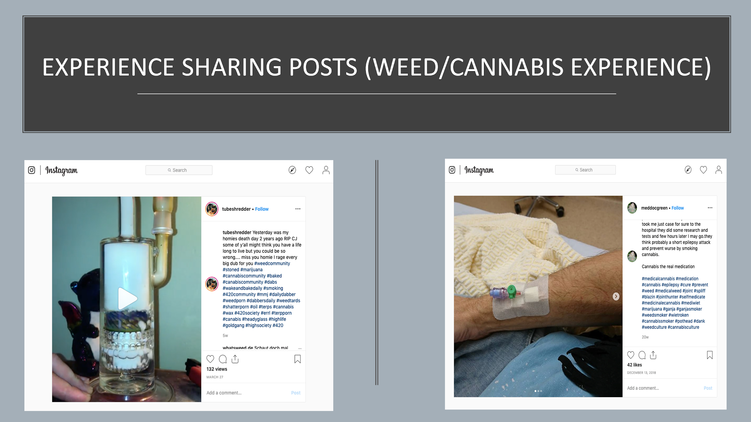

Figure 29. Family Addiction Experience Posts

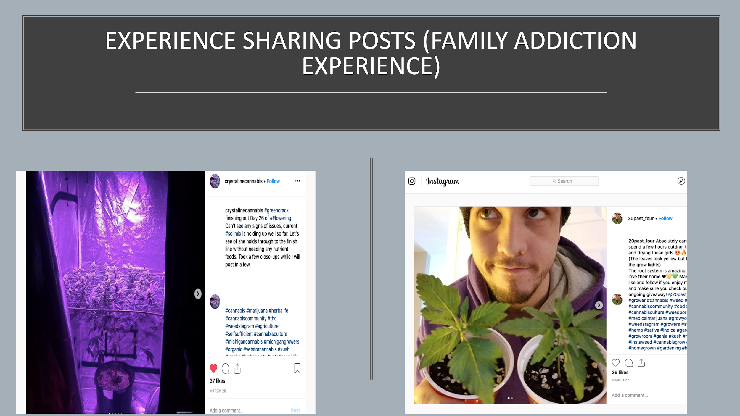

# FUTURE SCOPE

## Insights

Instagram can be considered as one of the legitimate sources to find illicit online marketing, sales, and consumption of controlled substances

Manually classify more posts to:

* Create classification models for the subcategories
* Train the classifiers and improve the accuracy of classifications

Extract image data of these posts and use Google Vision API to improve the classification

# APPENDIX

## CODE: for Aggregating All Extracted Text (Posts and Comments)

setwd('C:/Vignesh/Studies/Spring 19/Healthcare Analytics/Project/Comments')

#installing required libraries

library(readxl)

library(tidyverse)

library(stringi)

library(tm)

library(tmap)

library(corpus)

library(SnowballC)

install.packages("sos")

library("sos")

findFn("laply")

install.packages("plyr")

require(plyr)

library(stringr)

#Aggregating all posts

Instagram_opioid_scraped_data <- read_excel("C:/Vignesh/Studies/Spring 19/Healthcare Analytics/Project/Instagram_opioid_scraped_data.xlsx")

New_opioids04_03 <- read_excel("C:/Vignesh/Studies/Spring 19/Healthcare Analytics/Project/New_opioids04_03.xlsx")

Updated_Data <- read_excel("C:/Vignesh/Studies/Spring 19/Healthcare Analytics/Project/Files/Updated_Data.xlsx")

insta_new_data_04_03 <- read_excel("C:/Vignesh/Studies/Spring 19/Healthcare Analytics/Project/insta_new_data_04_03.xlsx")

agg <- rbind(Instagram_opioid_scraped_data,New_opioids04_03,Updated_Data,insta_new_data_04_03)

agg$description <- as.character(agg$description)

table(duplicated(agg$description))

agg_unique <- agg[!duplicated(agg$description), ]

str(agg_unique)

write.csv(agg_unique, file = "all_posts.csv")

#Code to aggregate Comments in batches

Post_url_1_to_35000 <- read_excel("C:/Vignesh/Studies/Spring 19/Healthcare Analytics/Project/Post_url_1_to_35000.xlsx")

split(Post_url_1_to_35000, (seq(nrow(Post_url_1_to_35000))-1) %/% 500)

newdata.split <- split(Post_url_1_to_35000, (as.numeric(rownames(Post_url_1_to_35000)) - 1) %/% 500)

str(newdata.split)

mydata <- as.data.frame(newdata.split)

write.csv(mydata, "post500urls.csv")

##Merge files

library(dplyr)

library(readr)

df <- list.files(path='C:/Vignesh/Studies/Spring 19/Healthcare Analytics/Project/Comments', full.names = TRUE) %>%

lapply(read_csv) %>%

bind_rows

write.csv(df, "commentsData_first35000.csv")

##Merge files

library(dplyr)

library(readr)

df <- list.files(path='C:/Vignesh/Studies/Spring 19/Healthcare Analytics/Project/comm', full.names = TRUE) %>%

lapply(read_csv) %>%

bind_rows

write.csv(df, "comments_35k_70k.csv")

comments <- df

comments$X9<-NULL

#Merging Comemnts and posts together

all_posts <- read.csv("C:/Vignesh/Studies/Spring 19/Healthcare Analytics/Project/Comments/all_posts.csv")

str(all_posts)

comments_1st_35k <- read.csv("C:/Vignesh/Studies/Spring 19/Healthcare Analytics/Project/Comments/comments_1st_35k.csv")

comments_2nd_35k <- read.csv("C:/Vignesh/Studies/Spring 19/Healthcare Analytics/Project/Comments/comments_2nd_35k.csv")

comments_3rd_35k <- read.csv("C:/Vignesh/Studies/Spring 19/Healthcare Analytics/Project/Comments/comments_3rd_35k.csv")

comments_1st_35k$X9<-NULL

comments_2nd_35k$X9<-NULL

comments_3rd_35k$X9<-NULL

Comm <- rbind(comments_1st_35k,comments_2nd_35k,comments_3rd_35k)

str(Comm)

write.csv(Comm,"All_Comments.csv")

All_Comments <- read.csv("C:/Vignesh/Studies/Spring 19/Healthcare Analytics/Project/Comments/All_Comments.csv")

all_posts_comments <- merge(x = all_posts, y = All_Comments, by = "postUrl", all = TRUE)

write.csv(all_posts_comments,"All_posts_Comments.csv")

table(is.na(all_posts_comments$comment))

backup_all_posts_comments <- all_posts_comments

apc <- all_posts_comments

str(apc)

#Removing rows which have NAs in Description Column

apc <- apc[!is.na(apc$description),]

apc <- apc[!is.na(apc$postUrl),]

str(apc)

apc_Text <- apc[,c("postUrl","description")]

table(duplicated(apc_Text$description))

apc_Text <- apc_Text[!duplicated(apc_Text$description),]

apc_Text['Type']='Post'

colnames(apc_Text)[which(names(apc_Text) == "description")] <- "Text"

#######################################

apc_Comment <- apc[,c("postUrl","comment")]

apc_Comment <- apc_Comment[!is.na(apc_Comment$comment),]

apc_Comment <- apc_Comment[!is.na(apc_Comment$postUrl),]

table(duplicated(apc_Comment$comment))

apc_Comment <- apc_Comment[!duplicated(apc_Comment$comment),]

apc_Comment['Type']='Comment'

colnames(apc_Comment)[which(names(apc_Comment) == "comment")] <- "Text"

apc_post_comm <- rbind(apc_Text, apc_Comment)

table(duplicated(apc_post_comm$Text))

apc_post_comm <- apc_post_comm[!duplicated(apc_post_comm$Text),]

str(apc_post_comm)

write.csv(apc_post_comm,"All_unique_posts_and_comments.csv")

## CODE: for Cleaning and Stemming

#Data Cleaning & Preprocessing

sent <- apc_post_comm$Text

sent<-gsub("[<].*[>]"," ",sent)

sent<-gsub("\r?\n|\r"," ",sent)

sent<-gsub(","," ",sent)

sent<-gsub(":"," ",sent)

sent<-gsub("+","",sent)

sent<-gsub("(","",sent)

sent<-gsub(")","",sent)

sent<-gsub("-","",sent)

sent<-gsub('([.])|[[:punct:]]',"\\1",sent)

sent<-gsub('[[:cntrl:]]'," ",sent)

apc_post_comm$Text <- sent

df <- apc_post_comm

df$Text <- gsub("[^\x20-\x7E]", "", df$Text)

df$Text <- gsub("[.{2,}]", "", df$Text)

library(stringr)

df$Text <- str_replace(gsub("\\s+", " ", str_trim(df$Text )), "B", "b")

apc_post_comm <- df

write.csv(apc_post_comm,"apc_post_comm_cleaned.csv")

tostem <-apc_post_comm

#Stemming and Freq words

docs <- Corpus(VectorSource(tostem$Text))

docs <-tm_map(docs,content_transformer(tolower))

#remove punctuation

docs <- tm_map(docs, removePunctuation)

#remove stopwords

docs <- tm_map(docs, removeWords, stopwords("english"))

#remove whitespace

docs <- tm_map(docs, stripWhitespace)

docs <- tm_map(docs,stemDocument, language = "english")

docs_df <- data.frame(text=sapply(docs, identity),stringsAsFactors=F)

afterstem <- cbind(tostem,docs_df)

colnames(afterstem)[which(names(afterstem) == "text")] <- "Stemmed_Text"

table(is.na(afterstem$text))

write.csv(afterstem,"Text_After_Stemming.csv")

## CODE: for Filtering and Scoring

#Data Filtering by matching bag of words and Scoring

word.match <- function(sentences,list.words){

scores<-laply(sentences,function(sentence,list.words){

word.list<-str_split(sentence,'\\s+')

words<-unlist(word.list)

pos.matches<-match(words,list.words)

pos.matches<-!is.na(pos.matches)

score<-sum(pos.matches)

return(score)

},list.words)

scores.df<-data.frame(score=scores,text=sentences)

return(scores.df)

}

BOW <- read.csv("C:/Vignesh/Studies/Spring 19/Healthcare Analytics/Project/Comments/BOW.csv")

#Remove all columns which are NAs

BOW <- BOW[,colSums(is.na(BOW))<nrow(BOW)]

table(is.na(BOW))

docs_Seller <- Corpus(VectorSource(BOW$BOW_Sellers))

docs_Consumer <- Corpus(VectorSource(BOW$BOW_Consumers))

docs_Edu_awar <- Corpus(VectorSource(BOW$BOW_Educ_Awar))

docs_Seller <-tm_map(docs_Seller,content_transformer(tolower))

docs_Consumer <-tm_map(docs_Consumer,content_transformer(tolower))

docs_Edu_awar <-tm_map(docs_Edu_awar,content_transformer(tolower))

docs_Seller <- tm_map(docs_Seller,stemDocument, language = "english")

docs_Consumer <- tm_map(docs_Consumer,stemDocument, language = "english")

docs_Edu_awar <- tm_map(docs_Edu_awar,stemDocument, language = "english")

docs_Seller_df <- data.frame(text=sapply(docs_Seller, identity),stringsAsFactors=F)

docs_Consumer_df <- data.frame(text=sapply(docs_Consumer, identity),stringsAsFactors=F)

docs_Edu_awar_df <- data.frame(text=sapply(docs_Edu_awar, identity),stringsAsFactors=F)

StemmedBOW <- NULL

StemmedBOW$Seller <- docs_Seller_df

StemmedBOW$Consumer <- docs_Consumer_df

StemmedBOW$Edu_awar <- docs_Edu_awar_df

StemmedBOW <- as.data.frame(StemmedBOW)

str(StemmedBOW)

colnames(StemmedBOW) <- c("Seller","Consumer","Edu_awar")

test.score.seller<- word.match(afterstem$Stemmed_Text,StemmedBOW$Seller)

colnames(test.score.seller) <- c("Seller_Score","Text")

test.score.consumer<- word.match(afterstem$Stemmed_Text,StemmedBOW$Consumer)

colnames(test.score.consumer) <- c("Consumer_Score","Text")

test.score.edu_awar<- word.match(afterstem$Stemmed_Text,StemmedBOW$Edu_awar)

colnames(test.score.edu_awar) <- c("Edu_awar_Score","Text")

textwithScores <- cbind(test.score.seller,test.score.consumer,test.score.edu_awar) #166401 observations

# REFERENCES

<https://www.instagram.com/>

<https://phantombuster.com/>

<https://www.jmir.org/2018/4/e10029/>

http://www.ncbi.nlm.nih.gow/pubmed/29049113

http://sproutsocial.com/insights/instagram-stats/

http://blog.hootsuite,com/instagram-statistics/

https://www.ncbi.nlm.nih.gov/pmc/articles/

<https://coschedule.com/blog/instagram-analytics/>

<https://123accs.com/instagram-account-age-checker/>